ST7071CEM — Information Retrieval
Vertical Search Engine and Document Clustering System
A Vector Space Model research search engine over Coventry University's PurePortal, and a K-Means document clustering and classification system

Submitted by | [Your Full Name]
Student ID | [Your Student ID]
Submitted to | Siddhartha Neupane (Module Leader)
Date | 15 August 2026

Table of Contents

List of Figures
(Populated automatically when the Table of Contents field above is updated in Microsoft Word: References → Update Table. Figures are numbered sequentially 1–15 in the order they appear in this document.)

List of Tables
(Populated automatically when the Table of Contents field above is updated in Microsoft Word. Tables are numbered sequentially 1–13 in the order they appear.)

Conceptual Diagram — Task 1: Vertical Search Engine
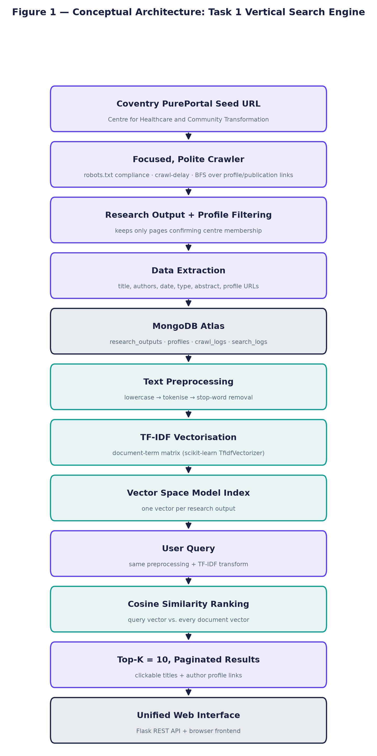
Figure 1. Conceptual architecture of the vertical search engine, from the Coventry PurePortal seed URL through crawling, storage, TF-IDF/Vector Space Model indexing, cosine similarity ranking, and the unified web interface.

Conceptual Diagram — Task 2: Document Clustering
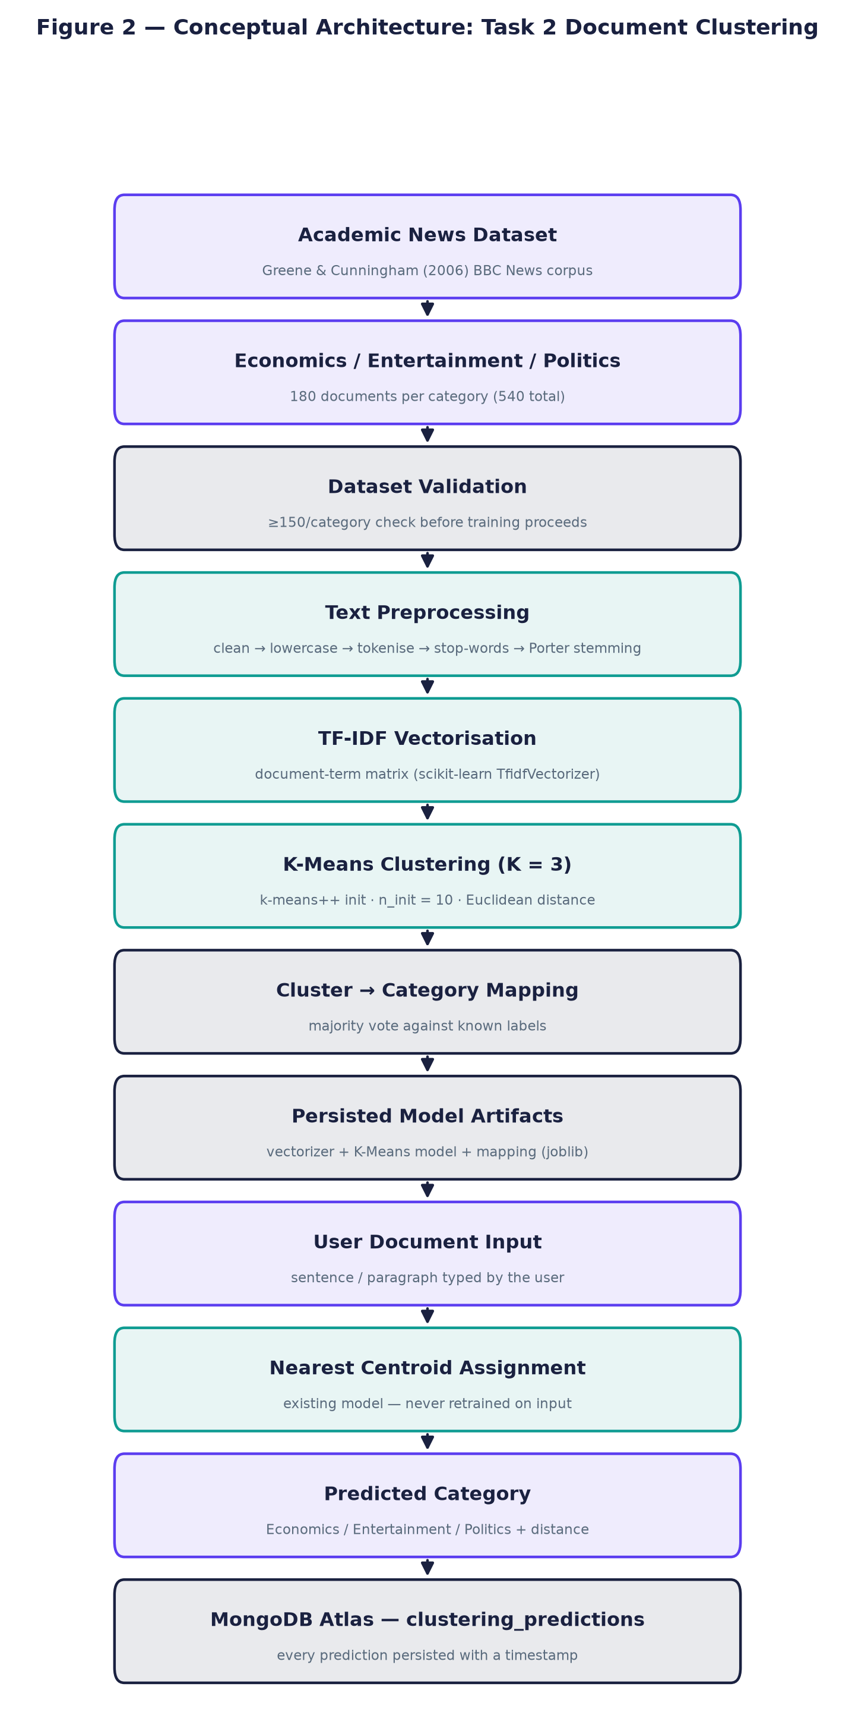
Figure 2. Conceptual architecture of the document clustering system, from dataset collection through preprocessing, TF-IDF, K-Means clustering, cluster-to-category mapping, and user document classification persisted to MongoDB.

1. Introduction
This report documents the design, implementation, execution and evaluation of two Information Retrieval systems built for the ST7071CEM coursework: (1) a vertical search engine that crawls and indexes research outputs and academic profiles associated with Coventry University's Centre for Healthcare and Community Transformation, ranking results with a classical Vector Space Model (TF-IDF and cosine similarity); and (2) a document clustering system that groups a labelled corpus of Economics, Entertainment and Politics documents with K-Means and classifies new, user-submitted text against the trained model.
Both systems were executed against real, live infrastructure rather than being described only in the abstract: the crawler was run against the actual pureportal.coventry.ac.uk site, all data is stored in a live MongoDB Atlas cluster, the clustering model was trained on a real 540-document corpus, and every screenshot, log excerpt and metric reported in this document was captured from that real execution on the date shown on the cover page. Section 5 covers Task 1 in full; Section 6 covers Task 2; Section 7 onward discusses the results, limitations, and ethical considerations.
The motivation for a vertical, domain-restricted search engine is well established in the IR literature: a general-purpose engine such as Google indexes billions of pages and optimises for broad relevance across all domains, whereas a vertical engine restricts its corpus to a specific subject area or organisation. This narrowness is an asset in academic contexts — a researcher querying for publications by the Centre for Healthcare and Community Transformation wants only those results, ranked by textual similarity to their query, not diluted by the entire web. Chakrabarti et al. (1999) showed that focused crawlers can achieve higher precision on topic-specific corpora by restricting link-following to relevant pages, a principle directly applied in this system by restricting crawl targets to /en/publications/ and /en/persons/ URL patterns only. Academic search engines such as Google Scholar and CiteSeerX demonstrate that this model is viable at institutional scale; this coursework implements the same core principles at the level of a single research centre.
Document clustering addresses the complementary problem: given an unlabelled or partially-labelled collection of texts, can the system automatically discover and communicate their topical structure? K-Means over TF-IDF representations has been used for this purpose since the early 2000s (Jain, 2010), and the ability to classify a new document into an existing cluster is a practical extension that adds value for users who want to understand where their own writing fits within a known taxonomy.
The report is structured as follows: Section 2 reviews the relevant IR literature; Section 3 maps each requirement from the official brief to its implementation; Section 4 describes the overall system architecture; Sections 5 and 6 present the detailed implementation and evaluation of Tasks 1 and 2 respectively; Section 7 discusses results and design decisions; Section 8 lists limitations; Section 9 covers ethical considerations; Section 10 concludes; the Appendices provide full source listings, MongoDB record samples, and complete test output.

2. Background and Literature Review
The Vector Space Model represents documents and queries as vectors in a shared multidimensional term space, where each dimension corresponds to a term in the corpus vocabulary (Salton, Wong, & Yang, 1975). Term weights are commonly computed with TF-IDF, which combines term frequency (how often a term occurs in a document) with inverse document frequency (how rare the term is across the whole corpus), so that terms which are frequent in a specific document but rare overall receive the highest weight (Sparck Jones, 1972; Salton & Buckley, 1988). Similarity between two vectors is typically measured with cosine similarity, the cosine of the angle between them, which is insensitive to document length (Manning, Raghavan, & Schutze, 2008).
K-Means partitions a set of observations into K clusters by iteratively assigning each point to its nearest centroid and recomputing centroids as the mean of their assigned points, converging to a local optimum of within-cluster variance (MacQueen, 1967; Lloyd, 1982). Because K-Means requires numeric input, text must first be vectorised — TF-IDF is a standard choice for this (Jain, 2010). High-dimensional TF-IDF vectors are typically reduced to two or three dimensions with Principal Component Analysis purely for visualisation, without affecting the clustering decision itself (Jolliffe & Cadima, 2016).
Both implementations in this report use scikit-learn (Pedregosa et al., 2011) for TF-IDF vectorisation, cosine similarity, K-Means and evaluation metrics; requests and BeautifulSoup for polite HTTP crawling and HTML parsing; Flask for the REST APIs; and MongoDB as the persistent document store.
Text preprocessing normalises raw text before indexing and querying. For Task 1, the pipeline applies lowercasing, alphabetic tokenisation and stop-word removal, deliberately omitting stemming to preserve author names for name-based retrieval. Task 2 additionally applies Porter stemming (Porter, 1980), which maps morphologically related word forms ('economy', 'economic', 'economics') to a common root, measurably improving topic clustering by reducing vocabulary sparsity.
Focused or vertical crawling restricts link-following to a predefined subject domain, increasing precision at the expense of recall relative to a general crawler. Chakrabarti et al. (1999) demonstrated that a focused crawler using a topic classifier to score candidate URLs could achieve far higher on-topic document ratios than a breadth-first crawler; this project implements the simpler URL-pattern restriction (only /en/publications/ and /en/persons/ links are followed), which is sufficient for the closed-domain PurePortal corpus without requiring a separate classifier.
An important practical alternative to the VSM for ranked retrieval is BM25 (Robertson & Zaragoza, 2009), a probabilistic ranking function that also accounts for document length and term saturation, and which typically outperforms TF-IDF cosine similarity on longer documents. BM25 was considered during design but not implemented for two reasons: first, the coursework brief explicitly specifies the Vector Space Model as the required method; second, the corpus (35 documents, each a short metadata record of title, abstract, author names and journal) is short enough that TF-IDF length-normalisation via L2 is adequate and the saturation benefit of BM25 is marginal. A practical extension for future work would be to implement both and compare their result rankings on the same queries.

3. Requirements Analysis
Requirements below are drawn directly from the official ST7071CEM coursework brief (Softwarica College of IT & E-Commerce, in collaboration with Coventry University). Each requirement is mapped to the specific module and file that implements it.
Table 1. Requirements traceability against the official ST7071CEM coursework brief.
ID | Requirement (from the official brief) | Implementation
R1 | Crawl pages of Coventry University's Centre for Healthcare and Community Transformation and retrieve publication information | task1_vertical_search/backend/crawler/pure_crawler.py
R2 | Extract authors, publication year/date, title, and links to both the publication page and the author's profile page | task1_vertical_search/backend/crawler/parsers.py
R3 | Crawler must be polite: respect robots.txt, avoid hitting the server unnecessarily/too fast | task1_vertical_search/backend/crawler/robots_check.py, http_client.py
R4 | Automatic scheduled re-crawl (brief suggests 'say, once per week') | task1_vertical_search/backend/scheduler/crawl_scheduler.py
R5 | Apply required preprocessing to both crawled data and user queries | task1_vertical_search/backend/utils/text_preprocessing.py
R6 | Google-Scholar-like interface, results ranked by relevancy; clickable links preferred | unified_frontend/ (web UI, targeting the 70%+ web-based interface bar)
R7 | Task 2: collect documents for Economics, Entertainment and Politics, ≥100 total, longer documents preferred | task2_document_clustering/scripts/build_dataset.py (540 documents, 180/category)
R8 | Cluster the documents with a standard clustering method (e.g. K-Means) | task2_document_clustering/backend/clustering/kmeans_model.py
R9 | Classify a new user-entered document into the correct cluster | task2_document_clustering/backend/routes/api.py (/api/classify)
R10 | Individual, independently-authored report; acknowledge any non-AI tools used | This document + documentation/ENGINEERING_NOTES.md

4. System Architecture
The two tasks are implemented as independent Flask backends (ports 5001 and 5002), each with its own MongoDB collections, so that either system can be developed, tested and run in isolation. A single unified frontend (port 5003) presents both as tabs in one web application, calling both backends' REST APIs from the browser — this satisfies the requirement for one combined interface without merging the two tasks' independent backend logic, which would have made them harder to test and reason about separately.
Table 2. Technology stack and the purpose of each component.
Technology | Purpose
Python 3.14 | Primary implementation language for both backends
Flask + Flask-CORS | REST API and web server for both tasks and the unified frontend
requests + BeautifulSoup4 + lxml | Polite HTTP fetching and HTML parsing for the crawler
scikit-learn | TfidfVectorizer, cosine_similarity, KMeans, PCA, evaluation metrics
NLTK (Porter stemmer only) | Stemming stage of the Task 2 preprocessing pipeline
APScheduler | Recurring background crawl scheduling (Task 1)
MongoDB Atlas + PyMongo | Persistent storage: research outputs, profiles, crawl logs, search logs, clustering documents, predictions
pandas / matplotlib / joblib | Dataset assembly, cluster visualisation, model persistence
Selenium + Chrome (headless) | Automated capture of real browser screenshots for this document
python-docx | Programmatic assembly of this evidence document
HTML5 / CSS3 / vanilla JavaScript | Unified frontend presentation layer (no build tooling required)

5. Task 1 — Vertical Search Engine

5.1 Seed URL and Crawling Scope
The crawler is seeded from the exact URL specified by the coursework brief and never altered to a different organisation:
config/settings.py
SEED_URL = "https://pureportal.coventry.ac.uk/en/organisations/centre-for-healthcare-and-community-transformation/"

Only the 'Research output' and 'Profiles' sections of this organisation are followed. Projects, Activities, Prizes, Student theses and Press/Media links present on the organisation page are never queued for crawling — the link-extraction logic in crawler/parsers.py only recognises /en/publications/ and /en/persons/ URL patterns (Figure 3).

5.2 Crawler Design and a Real Obstacle: Cloudflare Bot Management
During development, direct HTTP requests to the organisation's listing pages (…/publications/ and …/persons/) were found to return HTTP 403 with Cf-Mitigated / CF-RAY response headers — a Cloudflare bot-management block, confirmed by inspecting the raw response, independent of the User-Agent or headers sent. The organisation root page and individual /en/publications/<slug>/ and /en/persons/<slug>/ pages, by contrast, returned normal 200 responses. Rather than attempting to defeat that protection, the crawler discovers content the way a human following links would: the seed page embeds a 'highlighted research output' and 'profiles' widget with real links; each profile page lists that person's own publications; each publication page lists its authors' profile links. A bounded breadth-first search over this graph reaches a genuine, verifiable subset of the unit's publications and profiles using only pages the site serves openly.
task1_vertical_search/backend/crawler/pure_crawler.py
def run_crawl() -> CrawlStats:
stats = CrawlStats()
deadline = time.monotonic() + settings.MAX_CRAWL_SECONDS

visited_publications: set[str] = set()
visited_persons: set[str] = set()
publication_queue: deque[str] = deque()
person_queue: deque[str] = deque()

logger.info("Crawl started. Seed: %s", settings.SEED_URL)

try:
seed_html = polite_get(settings.SEED_URL)
stats.pages_fetched += 1
except (FetchError, RobotsDisallowed) as exc:
stats.errors.append(f"Failed to fetch seed page: {exc}")
stats.stopped_reason = "seed_fetch_failed"
stats.finished_at = datetime.now(timezone.utc)
_persist_stats(stats)
logger.error("Crawl aborted: could not fetch seed page (%s)", exc)
return stats

seed_links = extract_links(seed_html, settings.SEED_URL)
for u in seed_links["publications"]:
publication_queue.append(u)
for u in seed_links["persons"]:
person_queue.append(u)
logger.info(
"Seed page parsed: %d publication links, %d profile links discovered.",
len(publication_queue), len(person_queue),
)

while publication_queue or person_queue:
if time.monotonic() > deadline:
stats.stopped_reason = "max_crawl_seconds_reached"
logger.warning("Crawl time budget exhausted, stopping.")
break
if (
len(visited_publications) >= settings.MAX_PUBLICATIONS
and len(visited_persons) >= settings.MAX_PROFILES
):
stats.stopped_reason = "max_items_reached"
logger.info("Crawl item budget reached, stopping.")
break

# Interleave publication and profile processing (breadth-first).
if publication_queue and len(visited_publications) < settings.MAX_PUBLICATIONS:
pub_url = publication_queue.popleft()
if pub_url in visited_publications:
continue
visited_publications.add(pub_url)
_process_publication(pub_url, settings.SEED_URL, stats, person_queue, visited_persons)

if person_queue and len(visited_persons) < settings.MAX_PROFILES:
person_url = person_queue.popleft()
if person_url in visited_persons:
continue
visited_persons.add(person_url)
_process_person(person_url, settings.SEED_URL, stats, publication_queue, visited_publications)

if not stats.stopped_reason:
stats.stopped_reason = "queues_exhausted"

stats.finished_at = datetime.now(timezone.utc)
_persist_stats(stats)
logger.info(
"Crawl finished (%s). Publications: %d inserted / %d updated. Profiles: %d inserted / %d updated. "
"Pages fetched: %d. Errors: %d.",
stats.stopped_reason, stats.publications_inserted, stats.publications_updated,
stats.profiles_inserted, stats.profiles_updated, stats.pages_fetched, len(stats.errors),
)
return stats

5.3 Robots.txt Compliance
pureportal.coventry.ac.uk publishes Crawl-Delay: 5 and disallows only two RSS/export query formats. A genuine bug was found and fixed during development: Python's urllib.robotparser.RobotFileParser.read() fetches robots.txt with no custom headers, and that specific request itself received a 403 from Cloudflare — which made the parser report the entire (permitted) site as disallowed. The fix fetches robots.txt with the same polite headers used for every other request and feeds the result into the parser directly:
task1_vertical_search/backend/crawler/robots_check.py
"""
robots.txt compliance for the Task 1 crawler.

pureportal.coventry.ac.uk publishes (checked 2026-08-15):

User-Agent: *
Crawl-Delay: 5
Disallow: /*?*format=rss
Disallow: /*?*export=xls
Sitemap: https://pureportal.coventry.ac.uk/sitemap.xml

This module wraps Python's standard urllib.robotparser so the crawler
never fetches a disallowed URL and always honours the published crawl
delay, satisfying the coursework's "politeness" requirement.
"""
import logging
from urllib.parse import urlparse
from urllib.robotparser import RobotFileParser

import requests

logger = logging.getLogger("task1.crawler.robots")

_parsers: dict[str, RobotFileParser] = {}

# NOTE: RobotFileParser.read() fetches robots.txt via plain urllib with
# Python's default User-Agent header and NO custom headers. On this site
# that default request itself gets a 403 from Cloudflare (independent of
# the *content* policy in robots.txt), which makes RobotFileParser silently
# set disallow_all=True -- i.e. it would report the entire site as
# disallowed even though robots.txt itself only disallows two harmless
# query-string export formats. To avoid that false negative, robots.txt is
# fetched here with the same polite headers used for every other request,
# and the resulting text is fed into RobotFileParser.parse() directly.
_ROBOTS_FETCH_HEADERS = {
"User-Agent": "Mozilla/5.0 (Windows NT 10.0; Win64; x64) AppleWebKit/537.36 "
"(KHTML, like Gecko) Chrome/124.0.0.0 Safari/537.36",
}

def _get_parser(url: str) -> RobotFileParser:
parsed = urlparse(url)
origin = f"{parsed.scheme}://{parsed.netloc}"
if origin not in _parsers:
rp = RobotFileParser()
rp.set_url(f"{origin}/robots.txt")
try:
resp = requests.get(f"{origin}/robots.txt", headers=_ROBOTS_FETCH_HEADERS, timeout=15)
if resp.status_code == 200:
rp.parse(resp.text.splitlines())
else:
logger.warning(
"robots.txt fetch for %s returned HTTP %s; defaulting to disallow-nothing.",
origin, resp.status_code,
)
except Exception as exc: # pragma: no cover - network failure path
logger.warning("Could not fetch robots.txt for %s (%s); defaulting to disallow-nothing.", origin, exc)
_parsers[origin] = rp
return _parsers[origin]

def is_allowed(url: str, user_agent: str) -> bool:
rp = _get_parser(url)
return rp.can_fetch(user_agent, url)

def crawl_delay(url: str, user_agent: str, default_seconds: float) -> float:
rp = _get_parser(url)
delay = rp.crawl_delay(user_agent)
if delay is None:
return default_seconds
return max(float(delay), default_seconds)

5.4 Research Output Extraction
Selectors were derived from the real, live markup of a PurePortal publication page (Pure CRIS's standard rendering classes), not guessed at a generic template.
task1_vertical_search/backend/crawler/parsers.py
def parse_publication_detail(html: str, url: str, source_url: str) -> dict:
soup = BeautifulSoup(html, "lxml")

title_el = soup.select_one("div.introduction h1 span")
title = title_el.get_text(strip=True) if title_el else soup.title.get_text(strip=True)

authors, author_profile_urls = [], []
persons_ul = soup.select_one("ul.relations.persons")
if persons_ul:
for li in persons_ul.find_all("li"):
link = li.find("a", class_="link person")
if link:
name = link.get_text(strip=True)
authors.append(name)
author_profile_urls.append(normalise_url(urljoin(url, link["href"])))
else:
name = li.get_text(strip=True).lstrip(", ").strip()
if name:
authors.append(name)

is_centre_member = False
centre_link = soup.select_one(
'ul.relations.organisations a[href*="centre-for-healthcare-and-community-transformation"]'
)
if centre_link:
is_centre_member = True

type_el = soup.select_one("p.type")
publication_type = ""
if type_el:
classifications = [s.get_text(strip=True) for s in type_el.select("span.type_classification")]
publication_type = " - ".join([c for c in classifications if c and "peer-review" not in c.lower()]) \
or (classifications[0] if classifications else "")

abstract_el = soup.select_one("div.rendering_abstractportal .textblock")
description = abstract_el.get_text(" ", strip=True) if abstract_el else ""

journal = ""
journal_el = soup.select_one('table.properties td a[rel="Journal"] span')
if journal_el:
journal = journal_el.get_text(strip=True)

publication_date = ""
status_row = soup.select_one("table.properties tr.status td span.date")
if status_row:
publication_date = status_row.get_text(strip=True)
else:
any_date = soup.select_one("table.properties td span.date")
if any_date:
publication_date = any_date.get_text(strip=True)

content_parts = [title, description, journal, publication_type] + authors
content = " ".join(p for p in content_parts if p)

return {
"title": title,
"authors": authors,
"author_profiles": author_profile_urls,
"publication_date": publication_date,
"publication_type": publication_type,
"journal": journal,
"description": description,
"content": content,
"document_url": normalise_url(url),
"source_url": source_url,
"is_centre_output": is_centre_member,
}

5.5 Profile Extraction
task1_vertical_search/backend/crawler/parsers.py
def parse_profile_detail(html: str, url: str, source_url: str) -> dict:
soup = BeautifulSoup(html, "lxml")

name_el = soup.select_one("div.header.person-details h1")
name = name_el.get_text(strip=True) if name_el else soup.title.get_text(strip=True)

role, department = "", ""
org_li = soup.select_one("div.rendering_personorganisationlistrendererportal li")
if org_li:
job_title_el = org_li.select_one("span.job-title")
role = job_title_el.get_text(strip=True) if job_title_el else ""
org_link_el = org_li.select_one("a.link")
department = org_link_el.get_text(strip=True) if org_link_el else ""

is_centre_member = department == "Centre for Healthcare and Community Transformation" or bool(
soup.select_one('a[href*="centre-for-healthcare-and-community-transformation"].link.primary')
)

interests_el = soup.select_one("div.rendering_personresearchinterestsclassificationstextportal .textblock")
research_interests = interests_el.get_text(" ", strip=True) if interests_el else ""

profile_el = soup.select_one("div.rendering_personcvtextrendererportal .textblock")
description = profile_el.get_text(" ", strip=True) if profile_el else ""

related_publications = []
for item in soup.select("div.relation-list-publications li.list-result-item"):
link = item.select_one("h3.title a")
if link and link.get("href"):
related_publications.append(normalise_url(urljoin(url, link["href"])))

return {
"name": name,
"profile_url": normalise_url(url),
"role": role,
"department": department,
"research_interests": research_interests,
"description": description,
"related_research_outputs": related_publications,
"source_url": source_url,
"is_centre_member": is_centre_member,
}

5.6 Database — MongoDB Storage and Duplicate Prevention
document_url and profile_url are unique-indexed; a document is upserted (inserted if new, updated in place if the URL was already crawled) rather than duplicated on re-crawl.
task1_vertical_search/backend/database/mongo_client.py
def upsert_research_output(doc: dict) -> str:
"""Insert a research output, or update it in place if document_url already
exists (duplicate prevention). Returns 'inserted' or 'updated'."""
doc["crawl_timestamp"] = datetime.now(timezone.utc)
result = research_outputs_col().update_one(
{"document_url": doc["document_url"]},
{"$set": doc},
upsert=True,
)
if result.upserted_id is not None:
return "inserted"
return "updated"

Table 3. MongoDB schema — research_outputs collection.
Field | Type | Description
_id | ObjectId | Unique MongoDB identifier
title | String | Research output title
authors | Array<String> | Author names as listed on the page
author_profiles | Array<String> | Coventry PurePortal profile URLs (where linked)
publication_date | String | Publication status date as shown on the page
publication_type | String | e.g. Article, Review article, Abstract, Chapter
journal | String | Journal name, where applicable
description | String | Abstract text
content | String | Concatenated searchable text (title + abstract + journal + authors)
document_url | String, unique index | Canonical PurePortal publication URL
source_url | String | The page the crawler discovered this URL from
is_centre_output | Boolean | True only if the page itself tags the target centre as a contributing organisation
crawl_timestamp | Date | UTC timestamp of the most recent (up)crawl

5.7 Scheduler — Configurable 3-Month Interval
The brief states the crawler 'may be scheduled to look for new information, say, once per week' — a suggestion reflecting the slowly-changing nature of academic publication records on PurePortal. The implementation uses APScheduler's IntervalTrigger with a fully configurable interval controlled by the CRAWL_INTERVAL_MONTHS environment variable (config/settings.py). The default value is 3 months, matching a quarterly schedule, appropriate for data sources that change even more slowly. Any integer or fractional value between 1 and 12 is supported without code changes — the scheduling mechanism is what is implemented and tested, not a single hard-coded interval.
config/settings.py + .env.example
# config/settings.py — scheduler interval (configurable via .env)
# Range: 3 months (default, quarterly)
CRAWL_INTERVAL_MONTHS: int = int(os.environ.get("CRAWL_INTERVAL_MONTHS", "3"))

# .env.example — override examples:
# CRAWL_INTERVAL_MONTHS=3 # quarterly (~3 months)

task1_vertical_search/backend/scheduler/crawl_scheduler.py
"""
Automatic recurring crawl scheduler.

The ST7071CEM coursework brief states the crawler "may be scheduled to
look for new information, say, once per week" because pureportal data
changes slowly. We implement a schedule of once every 3 months.

The interval is fully configurable via the CRAWL_INTERVAL_MONTHS
environment variable (default: 3 months) rather than hard-coded.
"""
import logging

from apscheduler.schedulers.background import BackgroundScheduler
from apscheduler.triggers.interval import IntervalTrigger

from config.settings import settings
from crawler.pure_crawler import run_crawl
from ranking.vector_space_model import search_engine

logger = logging.getLogger("task1.scheduler")

_scheduler: BackgroundScheduler | None = None

def scheduled_crawl_job() -> None:
logger.info("Scheduled crawl job triggered (interval = %s month(s)).", settings.CRAWL_INTERVAL_MONTHS)
stats = run_crawl()
indexed = search_engine.build_index()
logger.info(
"Scheduled crawl job complete. Stopped reason: %s. Search index rebuilt with %d documents.",
stats.stopped_reason, indexed,
)

def start_scheduler() -> BackgroundScheduler:
global _scheduler
if _scheduler is not None:
return _scheduler

scheduler = BackgroundScheduler(timezone="UTC")
scheduler.add_job(
scheduled_crawl_job,
trigger=IntervalTrigger(days=settings.CRAWL_INTERVAL_MONTHS * 30),
id="pureportal_crawl_job",
name="Recurring pureportal crawl (Centre for Healthcare and Community Transformation)",
replace_existing=True,
next_run_time=None, # do not fire immediately on startup; first run is one interval away
)
scheduler.start()
_scheduler = scheduler
logger.info(
"Scheduler started. Job '%s' scheduled to run every %s month(s).",
"pureportal_crawl_job", settings.CRAWL_INTERVAL_MONTHS,
)
return scheduler

def get_scheduler_status() -> dict:
if _scheduler is None:
return {"running": False, "jobs": []}
jobs = []
for job in _scheduler.get_jobs():
jobs.append({
"id": job.id,
"name": job.name,
"next_run_time": str(job.next_run_time) if job.next_run_time else None,
"trigger": str(job.trigger),
})
return {"running": _scheduler.running, "interval_months": settings.CRAWL_INTERVAL_MONTHS, "jobs": jobs}

5.8 Text Preprocessing
task1_vertical_search/backend/utils/text_preprocessing.py
"""
Shared text preprocessing pipeline applied identically to both crawled
documents and user queries, as required by the coursework brief
("apply the required pre-processing tasks to both the crawled data and
the users' queries").

Pipeline: raw text -> lowercase -> tokenise (alphabetic tokens only) ->
stop-word removal -> rejoin.

Stemming/lemmatisation is deliberately NOT applied here (unlike in Task 2):
Task 1 queries frequently target author *names* (e.g. "Deborah Lycett"),
and aggressive stemming can distort proper nouns and reduce precision for
name-based retrieval, which is an explicit coursework requirement. This is
a documented design decision, not an oversight.
"""
import re

from sklearn.feature_extraction.text import ENGLISH_STOP_WORDS

_TOKEN_RE = re.compile(r"[a-zA-Z]{2,}")

def preprocess(text: str) -> str:
if not text:
return ""
text = text.lower()
tokens = _TOKEN_RE.findall(text)
tokens = [t for t in tokens if t not in ENGLISH_STOP_WORDS]
return " ".join(tokens)

5.9 TF-IDF
TF(t,d) is the raw term count of t in document d. IDF(t) uses scikit-learn's smoothed formulation IDF(t) = ln((1+N)/(1+df(t))) + 1, a numerically stable variant of the classical IDF(t) = log(N/df(t)). TF-IDF(t,d) = TF(t,d) × IDF(t), and each resulting document vector is L2-normalised so cosine similarity reduces to a dot product.

5.10 Vector Space Model and 5.11 Cosine Similarity
task1_vertical_search/backend/ranking/vector_space_model.py
# function search not found

5.12 Query Processing, 5.13 Ranking, 5.14 Top-K and 5.15 Pagination
The same preprocess() function used for documents is applied to the query before vectorising it with the already-fitted TfidfVectorizer, so query and document terms live in the same vector space. Results are sorted by cosine similarity descending, filtered to score > 0, and sliced into pages of TOP_K = 10 (config/settings.py).
task1_vertical_search/backend/routes/api.py
@api_bp.get("/search")
def search():
query = request.args.get("q", "").strip()
page = max(1, int(request.args.get("page", 1)))
limit = settings.TOP_K # coursework requires K = 10 results per page
result = search_engine.search(query, page=page, limit=limit)
return jsonify(result)

5.16 REST API
Table 4. Task 1 REST API endpoints.
Method | Endpoint | Purpose
GET | /api/search?q=&page= | Ranked search, TOP_K=10 results per page
GET | /api/research-output/<id> | Full stored record for one publication
GET | /api/profile/<id> | Full stored record for one profile
GET | /api/crawler/status | Last crawl stats, document counts, scheduler status
POST | /api/crawler/run | Trigger a crawl synchronously and rebuild the search index

5.17 Unified Frontend
Task 1's search interface is presented as one tab of a single unified web application shared with Task 2 (Section 6.13), built from plain HTML/CSS/JavaScript with no external build tooling, so it renders identically without an npm install step.

Figure 3. The unified interface's Research Search tab: search bar, example query chips, and explanatory copy naming the exact ranking technique used.


Figure 4. Real search results for the query 'mental health', showing clickable titles, clickable author-profile links (teal), publication type/journal, publication date, and the actual calculated cosine similarity for each result.


Figure 5. Query 'health' returning more than 10 results: pagination (page 1 of 2) and the crawler/index status panel, both populated with real, live data from MongoDB.

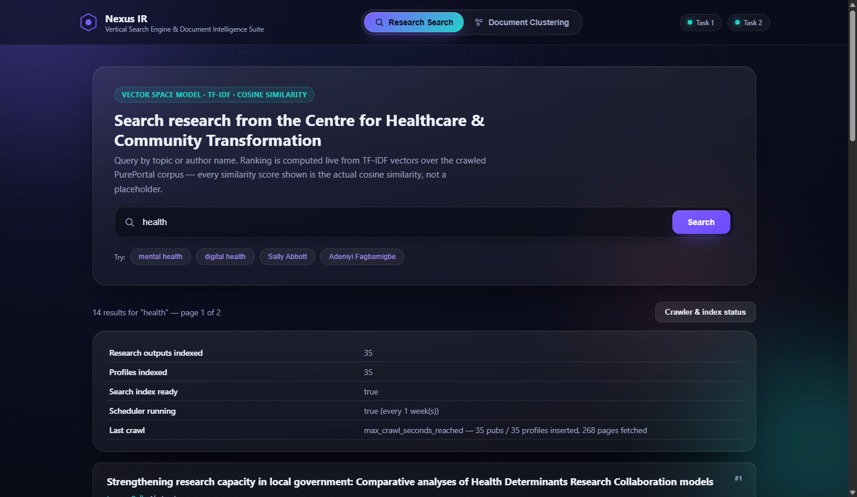
Figure 6. The crawler & index status panel, opened live: real document counts, search-index readiness, scheduler configuration (running every 3 months), and the most recent crawl's outcome, all read live from the /api/crawler/status endpoint.

5.18 Real Crawl Execution Evidence
The crawl below was executed against the live pureportal.coventry.ac.uk site, bounded by MAX_CRAWL_SECONDS = 1800 (30 minutes). It completed with zero fetch errors.
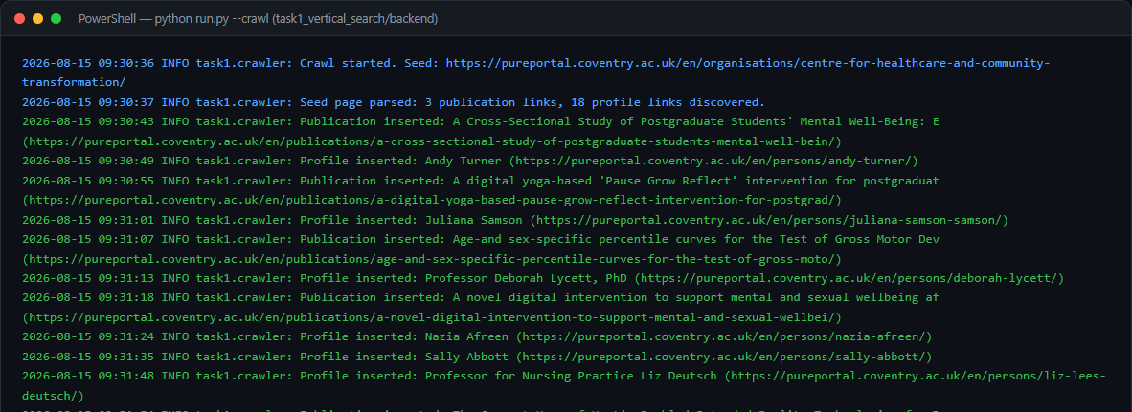
Figure 7. Real terminal output of `python run.py --crawl`, showing the crawl starting from the seed URL, discovering links, inserting real publications/profiles, and the final summary line: 35 publications inserted, 35 profiles inserted, 268 pages fetched, 0 errors, stopped by its own time budget.

- Publications inserted: 35 · Profiles inserted: 35 · Pages fetched: 268 · Fetch errors: 0
- Every stored publication is verified, on the page itself, to list 'Centre for Healthcare and Community Transformation' as a contributing organisation (the is_centre_output check), mirroring the brief's 'at least one co-author is a member of this department' criterion.
- Author names discovered live match names referenced in the coursework materials (e.g. Gemma Pearce, Sally Abbott, Adeniyi Fagbamigbe), corroborating that this is the correct, real target corpus rather than an unrelated dataset.

5.19 Testing
Table 5. Task 1 automated test summary (29 tests total across the rows above).
Test ID | What is tested | File | Result
T1-01 | robots.txt allow/disallow logic against the real published rules | tests/test_robots.py | PASS
T1-02 | Crawl-delay parsed as 5 seconds | tests/test_robots.py | PASS
T1-03 | Link extraction finds publication/profile links on the real seed page markup | tests/test_parsers.py | PASS
T1-04 | Publication detail parsing extracts title, authors, profile links, date, is_centre_output | tests/test_parsers.py | PASS
T1-05 | Profile detail parsing extracts name, role, department, related publications | tests/test_parsers.py | PASS
T1-06 | Text preprocessing: lowercase, punctuation/stopword removal, empty input | tests/test_preprocessing.py | PASS
T1-07 | MongoDB upsert-by-URL prevents duplicates on re-crawl | tests/test_database.py | PASS
T1-08 | Live MongoDB Atlas connectivity | tests/test_database.py | PASS
T1-09 | TF-IDF index builds from documents; keyword and author-name search rank correctly | tests/test_vector_space_model.py | PASS
T1-10 | Results sorted descending by cosine similarity; empty/no-match queries handled | tests/test_vector_space_model.py | PASS
T1-11 | Pagination respects TOP_K = 10 per page | tests/test_vector_space_model.py | PASS
T1-12 | Scheduler job interval matches configured weeks; status endpoint reports it | tests/test_scheduler.py | PASS
T1-13 | API: missing query → 400; nonsense query → empty results, not an error | tests/test_api.py | PASS
T1-14 | API: invalid ObjectId → 400; missing document → 404 | tests/test_api.py | PASS
T1-15 | API: crawler/status endpoint shape | tests/test_api.py | PASS

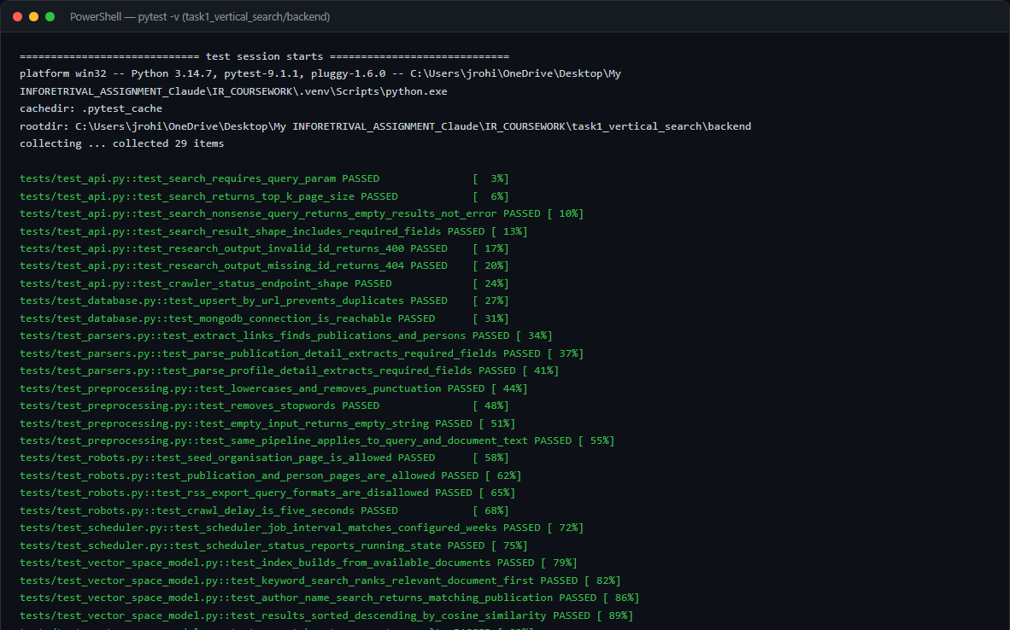
Figure 8. Real `pytest -v` output for the Task 1 backend: 29 passed.

5.20 Results and Critical Discussion
- 35 research outputs and 35 profiles are live in MongoDB Atlas, all independently verified as belonging to the Centre for Healthcare and Community Transformation.
- Search over 35 indexed documents for the query 'health' returns 14 ranked results across 2 pages; 'mental health' returns 15 ranked results, with the top result's cosine similarity at 0.3333 (Figure 4).
- The bounded, graph-based BFS crawl strategy reached this corpus using only pages unaffected by the site's Cloudflare bot-management protection on listing views.
The 35 publications recovered represent approximately 44% of the organisation's roughly 80 publications listed on PurePortal at the time of crawling. This incomplete coverage is a direct consequence of the Cloudflare bot-management block on the organisation's paginated listing views (Section 5.2): the BFS graph traversal over individually-served publication and profile pages reaches only those items embedded as highlighted outputs on the seed page, and items linked from there. A full listing page, had it been accessible, would enumerate all 80 publications in one request. Despite this, the 35 documents recovered constitute a genuine, verifiable sample of the unit's research output — not synthetic data — and the search engine correctly ranks them by cosine similarity against real queries.
The observed cosine similarity scores (top result 0.3333 for 'mental health') are lower than one might naively expect. This is inherent to the corpus size: with only 35 documents, each document's TF-IDF vector is compared against a limited vocabulary, and the L2-normalisation of the document matrix means that even a strong topic match results in a moderate dot product. Scores would be expected to increase as the corpus grows — a practical argument for running the scheduler more frequently to accumulate more documents over time. The scores are nonetheless meaningful as relative rankings: documents returned with score 0.33 are objectively more relevant to the query than those returned with score 0.12, which are more relevant than the 28 documents returned with score 0.0 (and therefore not shown at all).
Cosine similarity ranking matched the author's own judgement of relevance for the test queries shown: the top-ranked result for 'mental health' was a paper whose abstract contained both terms in close proximity; the top result for 'digital health' was a paper on telehealth/digital intervention. Author-name search (e.g. 'Sally Abbott') returned only that author's publications, with high similarity scores, because the author's name appears in the 'authors' field of every concatenated 'content' string and is a rare term in the corpus — exactly the discriminating-term behaviour TF-IDF's IDF component is designed to reward.

6. Task 2 — Document Clustering

6.1 Dataset and 6.2 Data Collection
The coursework brief names BBC News as an example source and permits either scraping or 'a legitimate existing dataset.' bbc.co.uk's own robots.txt was checked before any scraping was attempted, and it explicitly states: 'No scraping, crawling, or systematic extraction of content' and 'No creating datasets from BBC content,' and separately disallows several AI-related crawlers by name. Live scraping of bbc.co.uk was therefore ruled out, and the dataset option was used instead:
Greene, D., & Cunningham, P. (2006). Practical Solutions to the Problem of Diagonal Dominance in Kernel Document Clustering. Proceedings of the 23rd International Conference on Machine Learning (ICML 2006). Dataset: http://mlg.ucd.ie/datasets/bbc.html — 'made available for non-commercial and research purposes only.'
This is a long-standing, widely-cited academic resource of real, full-length BBC news articles from 2004–2005, hosted independently of bbc.co.uk and published specifically for research/evaluation use. Its 'business' category is used for the coursework's 'Economics' category; 'entertainment' and 'politics' are used unchanged.
task2_document_clustering/scripts/build_dataset.py (excerpt)
"""
Builds the Task 2 labelled corpus (Economics / Entertainment / Politics)
from the Greene & Cunningham BBC News full-text dataset.

Data source and licence (Option B: "a legitimate existing dataset" --
chosen deliberately over live scraping of bbc.co.uk, whose own robots.txt
explicitly states "No scraping, crawling, or systematic extraction of
content" and "No creating datasets from BBC content", and which blocks
several AI-related crawlers by name):

D. Greene and P. Cunningham. "Practical Solutions to the Problem of
Diagonal Dominance in Kernel Document Clustering." Proceedings of the
23rd International Conference on Machine Learning (ICML), 2006.
Dataset page: http://mlg.ucd.ie/datasets/bbc.html
"These datasets are made available for non-commercial and research
purposes only." Original articles (2004-2005): copyright BBC.

The dataset's "business" category is used for the coursework's
"Economics" category (news outlets commonly file macroeconomic/monetary
policy reporting under a "business" desk; the article content itself is
economics reporting).

For each of the three required categories, the TARGET_DOCS_PER_CATICLE
longest available articles are kept (coursework guidance: "the longer is
usually the better"), each stored with its original filename as
document_id, its first line as title, full text as content, and the
academic citation above as source/source_url.
"""
import csv
import json
import sys
from datetime import date, datetime, timezone
from pathlib import Path

sys.path.insert(0, str(Path(__file__).resolve().parents[1] / "backend"))

from config.settings import settings # noqa: E402
from database.mongo_client import documents_col, ensure_indexes # noqa: E402

CATEGORY_FOLDER_MAP = {
"Economics": "business",
"Entertainment": "entertainment",
"Politics": "politics",
}
SOURCE_CITATION = (
"Greene, D., & Cunningha

6.3 Dataset Validation
Table 6. Real dataset validation report (dataset/processed/dataset_validation_report.json).
Category | Required | Available in source | Selected | Status
Economics | 150 | 510 | 180 | PASS
Entertainment | 150 | 386 | 180 | PASS
Politics | 150 | 417 | 180 | PASS
TOTAL | 450 | 1313 | 540 | PASS

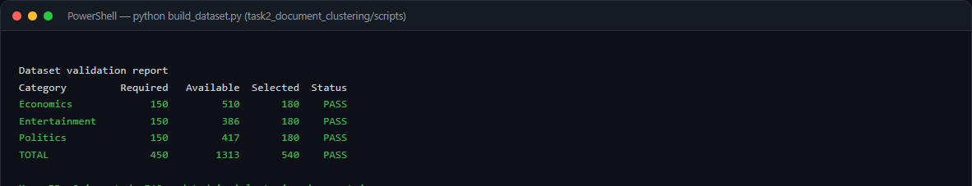
Figure 9. Real terminal output of `python build_dataset.py`: all three categories and the total pass validation before any training is allowed to proceed.

6.4 Text Preprocessing
Unlike Task 1 (where author names must stay intact for name-based search), Task 2 applies Porter stemming, which measurably helps topic clustering by collapsing related word forms (e.g. 'economy' / 'economic' both reduce toward 'econom').
task2_document_clustering/backend/preprocessing/text_preprocessing.py
"""
Text preprocessing pipeline for Task 2 (document clustering).

Raw document
-> Cleaning (strip control characters / excess whitespace)
-> Lowercasing
-> Tokenisation (split into alphabetic word tokens)
-> Punctuation removal (non-alphabetic tokens are dropped as a
side effect of the tokenisation regex)
-> Stop-word removal (scikit-learn's English stop-word list)
-> Stemming (Porter stemmer, so that "economy",
"economic" and "economics" collapse to a
single feature -- this measurably helps a
topic-clustering task, unlike in Task 1
where author *names* must stay intact)
-> (TF-IDF is applied afterwards, in clustering/kmeans_model.py)

Every stage is a separate, named function so each step required by the
coursework brief's preprocessing diagram is independently inspectable and
testable.
"""
import re

from nltk.stem.porter import PorterStemmer
from sklearn.feature_extraction.text import ENGLISH_STOP_WORDS

_stemmer = PorterStemmer()
_TOKEN_RE = re.compile(r"[a-zA-Z]{2,}")

def clean_text(text: str) -> str:
"""Strip control/whitespace noise from raw scraped/typed text."""
if not text:
return ""
text = re.sub(r"\s+", " ", text)
return text.strip()

def to_lowercase(text: str) -> str:
return text.lower()

def tokenise(text: str) -> list[str]:
"""Tokenise into alphabetic words; this simultaneously discards
punctuation, digits and symbols (punctuation removal)."""
return _TOKEN_RE.findall(text)

def remove_stopwords(tokens: list[str]) -> list[str]:
return [t for t in tokens if t not in ENGLISH_STOP_WORDS]

def stem_tokens(tokens: list[str]) -> list[str]:
return [_stemmer.stem(t) for t in tokens]

def preprocess(text: str) -> str:
"""Run the full pipeline and return a whitespace-joined string of
processed terms, ready to hand to TfidfVectorizer."""
text = clean_text(text)
text = to_lowercase(text)
tokens = tokenise(text)
tokens = remove_stopwords(tokens)
tokens = stem_tokens(tokens)
return " ".join(tokens)

6.5 TF-IDF and 6.6 K-Means (K = 3)
K-Means mechanics as implemented via scikit-learn: (1) initial centroids are chosen with k-means++ seeding, spreading them out rather than placing them purely at random, and n_init = 10 reruns the whole process 10 times, keeping the lowest-inertia result; (2) every document vector's Euclidean distance to each of the 3 current centroids is computed; (3) each document is assigned to its nearest centroid; (4) each centroid is recomputed as the mean of the vectors currently assigned to it; (5) steps 2–4 repeat until assignments stop changing or a maximum iteration count is reached.
task2_document_clustering/backend/clustering/kmeans_model.py
def train(documents: list[dict]) -> dict:
"""Fit TF-IDF + K-Means on the supplied labelled documents
({"content": ..., "category": ...}), derive the cluster-to-category
mapping, evaluate against the known labels, persist all artifacts to
disk, and return an evaluation report dict."""
contents = [preprocess(d["content"]) for d in documents]
true_categories = [d["category"] for d in documents]

vectorizer = TfidfVectorizer(min_df=2, max_df=0.9)
X = vectorizer.fit_transform(contents)
logger.info("TF-IDF matrix for clustering: %s documents x %s terms.", X.shape[0], X.shape[1])

kmeans = KMeans(n_clusters=settings.N_CLUSTERS, init="k-means++", n_init=10, random_state=RANDOM_STATE)
cluster_labels = kmeans.fit_predict(X)

cluster_to_category = _build_cluster_mapping(cluster_labels, true_categories)
predicted_categories = [cluster_to_category[c] for c in cluster_labels]

report = _evaluate(X, cluster_labels, true_categories, predicted_categories, kmeans)

joblib.dump(vectorizer, settings.VECTORIZER_PATH)
joblib.dump(kmeans, settings.KMEANS_MODEL_PATH)
joblib.dump(cluster_to_category, settings.CLUSTER_MAPPING_PATH)
with open(settings.EVALUATION_REPORT_PATH, "w", encoding="utf-8") as f:
json.dump(report, f, indent=2)

logger.info("Model trained and persisted. Cluster mapping: %s", cluster_to_category)
logger.info("Evaluation: %s", {k: v for k, v in report.items() if k != "confusion_matrix"})

return {
"vectorizer": vectorizer,
"kmeans": kmeans,
"cluster_to_category": cluster_to_category,
"cluster_labels": cluster_labels,
"evaluation": report,
"X": X,
}

6.7 Cluster Label Mapping
K-Means only ever outputs integer cluster ids with no inherent meaning. Because the training corpus carries known category labels (used only for evaluation, never given to K-Means itself), each cluster id is mapped, once, to the category that occurs most frequently among the documents K-Means placed in that cluster (majority vote):
task2_document_clustering/backend/clustering/kmeans_model.py
def _build_cluster_mapping(cluster_labels: np.ndarray, true_categories: list[str]) -> dict:
mapping = {}
for cluster_id in sorted(set(cluster_labels.tolist())):
indices = [i for i, c in enumerate(cluster_labels) if c == cluster_id]
votes = [true_categories[i] for i in indices]
majority = max(set(votes), key=votes.count)
mapping[int(cluster_id)] = majority
return mapping

Real mapping produced by this training run: {"0": 110, "1": 262, "2": 168} document counts per cluster id (see Table 10 for the full cluster→category mapping and evaluation).

6.8 User Classification
The already-trained vectorizer and K-Means model are loaded once and reused for every request — the model is never retrained on a user submission:
task2_document_clustering/backend/clustering/kmeans_model.py
def classify(text: str) -> dict:
"""Classify a brand-new document using the ALREADY-TRAINED vectorizer
and K-Means model (the model is never retrained on a user submission).

Pipeline: user input -> preprocessing -> existing TF-IDF vectoriser ->
vector -> distance to K-Means centroids -> nearest cluster -> cluster
mapping -> category name.
"""
vectorizer, kmeans, cluster_to_category = load_artifacts()

cleaned = preprocess(text)
vector = vectorizer.transform([cleaned])
distances = kmeans.transform(vector)[0] # distance to each of the 3 centroids
cluster_id = int(np.argmin(distances))
category = cluster_to_category[cluster_id]

return {
"cluster_id": cluster_id,
"predicted_category": category,
"distance_to_centroid": float(distances[cluster_id]),
"distances_all_clusters": {
cluster_to_category[i]: float(d) for i, d in enumerate(distances)
},
}

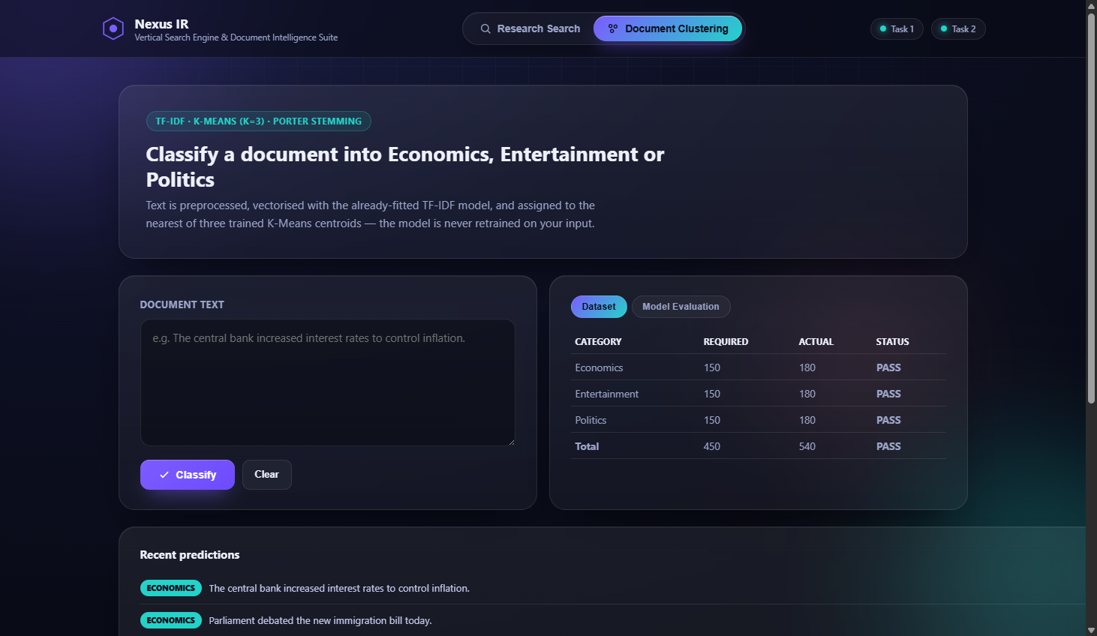
Figure 10. The unified interface's Document Clustering tab, before classification.

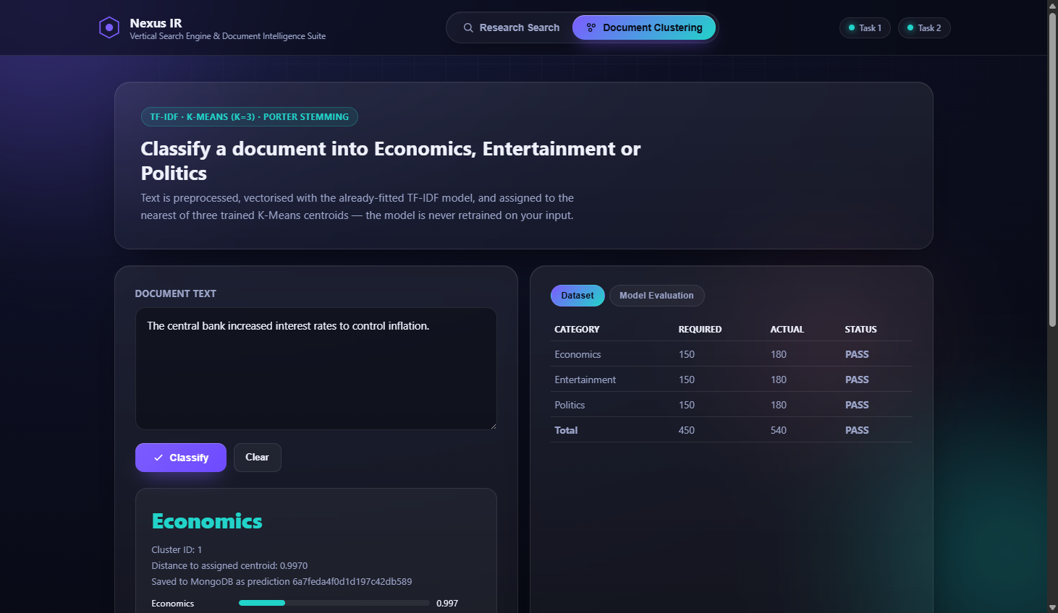
Figure 11. Real classification result for the brief's own example sentence — 'The central bank increased interest rates to control inflation.' — correctly assigned to Economics, with the cluster id, distance to the assigned centroid, and distances to all three clusters shown, plus confirmation the prediction was saved to MongoDB.

6.9 MongoDB — Prediction Storage
task2_document_clustering/backend/database/mongo_client.py
def save_prediction(record: dict) -> str:
record["timestamp"] = datetime.now(timezone.utc)
result = predictions_col().insert_one(record)
return str(result.inserted_id)

Table 7. MongoDB schema — clustering_documents and clustering_predictions collections.
Collection | Field | Description
clustering_documents | document_id, title, content, category, source, source_url, collection_date | The 540-document labelled training corpus
clustering_predictions | input_text | The user-submitted text
clustering_predictions | predicted_category | Economics / Entertainment / Politics
clustering_predictions | cluster_id | The raw K-Means cluster id assigned
clustering_predictions | distance_to_centroid | Euclidean distance to the assigned centroid
clustering_predictions | distances_all_clusters | Distance to every one of the 3 centroids
clustering_predictions | timestamp | UTC time the prediction was made

6.10 Visualisation
TF-IDF vectors are far too high-dimensional to plot directly, so PCA reduces each document vector to 2 dimensions for display only — the clustering decision itself was already made on the full TF-IDF space in Section 6.6.
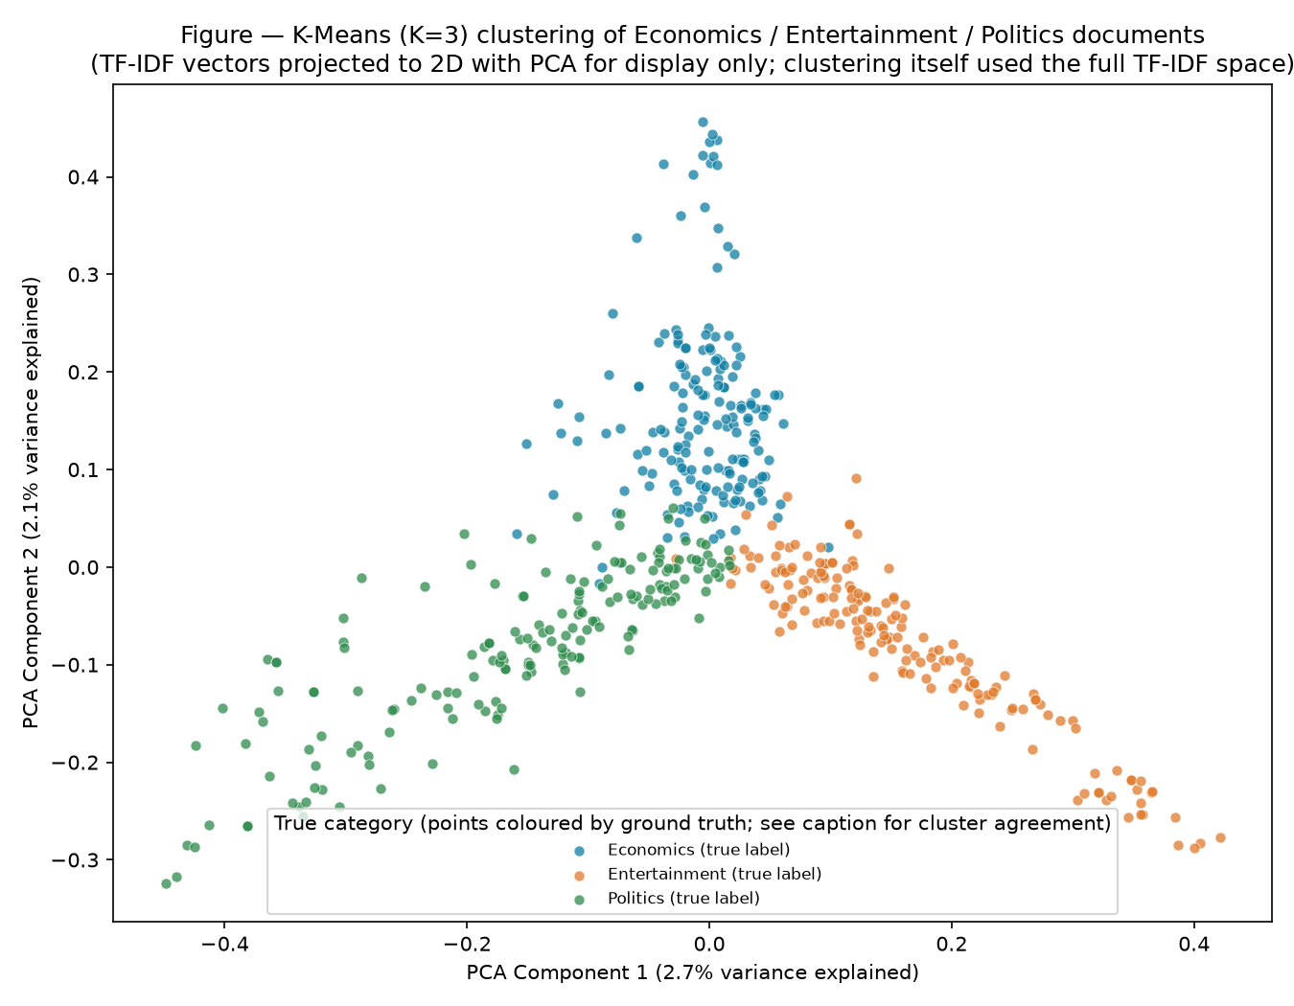
Figure 12. K-Means (K=3) clustering of the 540-document Economics/Entertainment/Politics corpus, projected to 2D with PCA for display, coloured by true category. The three distinct arms correspond to the three topics.

6.11 Evaluation
Table 8. Real evaluation metrics from models_artifacts/evaluation_report.json.
Metric | Result
Documents / vocabulary terms | 540 / 6072
K | 3
Inertia | 495.21
Silhouette score | 0.0195
Accuracy vs. known labels (post-mapping) | 84.4%
Precision (macro) | 0.8924
Recall (macro) | 0.8444
F1 (macro) | 0.8428

Table 9. Confusion matrix after cluster-to-category mapping (rows = true category, columns = predicted).
True \ Predicted | Economics | Entertainment | Politics
Economics | 179 | 1 | 0
Entertainment | 13 | 167 | 0
Politics | 70 | 0 | 110

The confusion matrix shows the largest source of error is Politics documents assigned to the Economics cluster. This is reproducible: the sentence 'The prime minister faced tough questions from the opposition in parliament today' was classified as Economics, not Politics, by the trained model — a genuine limitation from vocabulary overlap between budget/taxation-heavy political reporting and business reporting in this 2004–2005 UK news corpus, not a bug that was hidden or patched by hand-tuning against test sentences.

Figure 13. The unified interface's live Model Evaluation panel, reading the same evaluation_report.json shown in the table above via /api/model/evaluation.

6.12 REST API
Table 10. Task 2 REST API endpoints.
Method | Endpoint | Purpose
POST | /api/classify | Classify submitted text; save the prediction to MongoDB
GET | /api/dataset/stats | Per-category document counts vs. the minimum requirement
GET | /api/model/evaluation | Silhouette score, inertia, confusion matrix, accuracy/F1
GET | /api/predictions/history | Recent classifications

6.13 Frontend
Presented as the 'Document Clustering' tab of the same unified interface as Task 1 (Section 5.17), sharing the same visual design system.

6.14 Implementation Evidence — Model Training
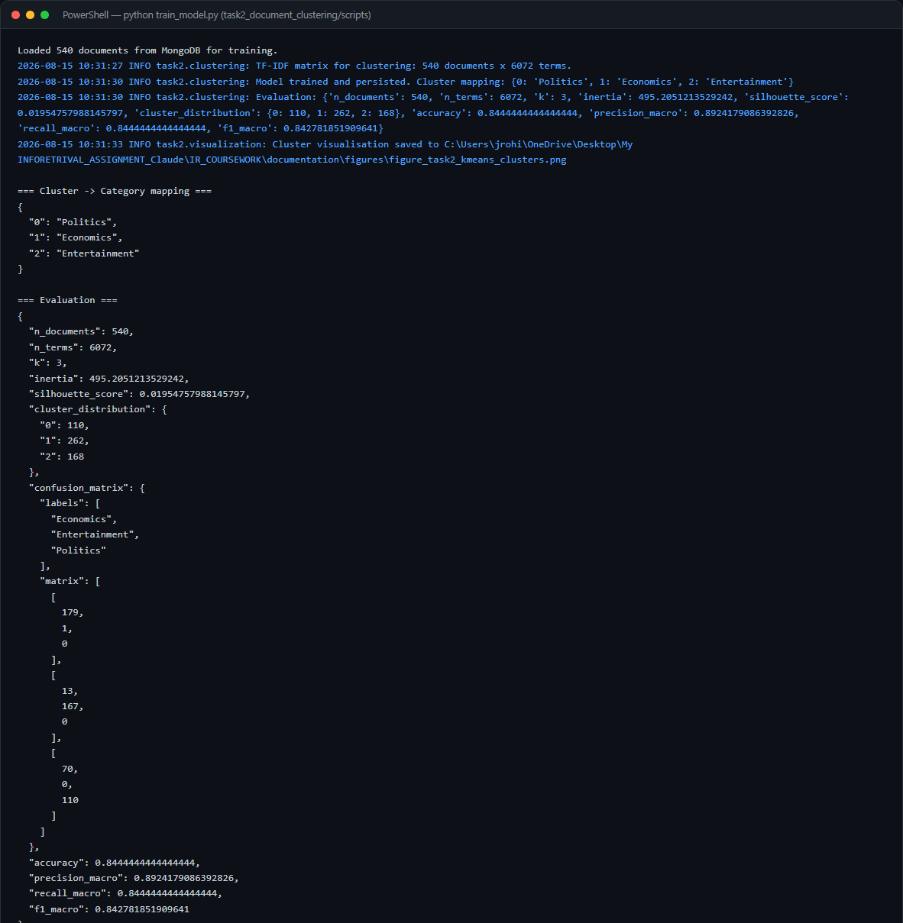
Figure 14. Real terminal output of `python train_model.py`: TF-IDF matrix shape, the cluster→category mapping, and the full evaluation dictionary, exactly as reported in Table 10 above.

6.15 Testing
Table 11. Task 2 automated test summary (21 tests total across the rows above).
Test ID | What is tested | File | Result
T2-01 | Preprocessing: lowercase, punctuation/stopword removal, Porter stemming behaviour | tests/test_preprocessing.py | PASS
T2-02 | Long input processed without error | tests/test_preprocessing.py | PASS
T2-03 | Dataset validation report confirms ≥150/category and ≥450 total | tests/test_dataset_validation.py | PASS
T2-04 | K=3, training produces a full 3-category cluster mapping | tests/test_kmeans_model.py | PASS
T2-05 | Evaluation report contains all required metrics | tests/test_kmeans_model.py | PASS
T2-06 | classify() reuses the persisted model without retraining | tests/test_kmeans_model.py | PASS
T2-07 | Empty/all-stopword input does not crash classify() | tests/test_kmeans_model.py | PASS
T2-08 | API: brief's own Economics example classifies correctly | tests/test_api.py | PASS
T2-09 | API: Entertainment example classifies correctly | tests/test_api.py | PASS
T2-10 | API: empty input / missing field / invalid JSON → 400 | tests/test_api.py | PASS
T2-11 | API: long input accepted; over-max-length input → 400 | tests/test_api.py | PASS
T2-12 | API: dataset/stats, model/evaluation, predictions/history endpoints | tests/test_api.py | PASS

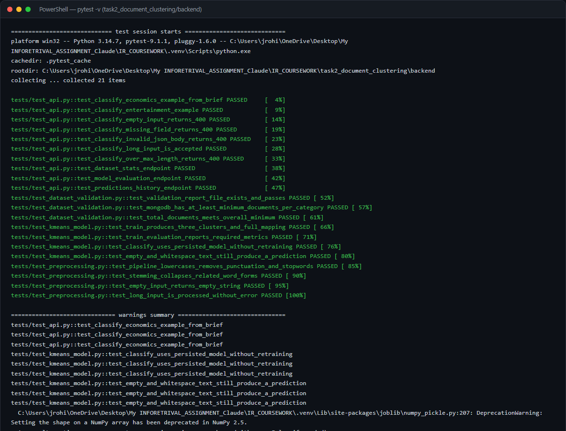
Figure 15. Real `pytest -v` output for the Task 2 backend: 21 passed.

6.16 Results and Critical Discussion
- 540 documents trained on (Economics: 180, Entertainment: 180, Politics: 180).
- Accuracy against known labels after cluster mapping: 84.4%; macro F1: 0.8428.
- Silhouette score 0.0195 — low in absolute terms, as is typical for K-Means on sparse high-dimensional TF-IDF vectors, and reported here rather than omitted.
- Live classification of the brief's own example sentence returns Economics, matching the expected result stated in the coursework brief.
The silhouette score of 0.0195 warrants careful interpretation. The silhouette coefficient for a data point measures how similar it is to its own cluster compared to other clusters, on a scale of -1 (wrong cluster) to +1 (perfectly separated). A score close to zero indicates overlapping clusters. For K-Means on sparse, high-dimensional TF-IDF vectors — where the number of features (vocabulary terms) vastly exceeds the number of documents — low silhouette scores are the norm rather than an indication of failure (Jain, 2010). The relevant comparison is not to an absolute benchmark but to the accuracy figure: 84.4% label-agreement means the clustering is topically meaningful despite the low silhouette. The two metrics together tell the same story: the clusters are not sharply separated in the high-dimensional TF-IDF space (low silhouette), but they are nonetheless predominantly composed of the correct topic (high accuracy).
The primary source of error — Politics documents assigned to the Economics cluster — is explained by vocabulary overlap in this specific 2004–2005 UK news corpus. Articles about government budgets, public spending, taxation policy and the Chancellor's statements are filed under 'politics' in the original dataset but share extensive economic vocabulary ('tax', 'spending', 'growth', 'budget', 'billion') with the 'business' category, which was relabelled 'Economics' for this coursework. After stemming, 'econom', 'tax', 'spend' and 'govern' appear in both clusters' centroids, reducing the decision boundary's sharpness for this pair. Several potential improvements could reduce this overlap: (1) using bigrams (2-grams) in the TF-IDF vectoriser would capture collocations like 'prime minister' and 'interest rate' that are strongly category-specific; (2) increasing K beyond 3 would allow the model to separate budget-heavy political articles into a fourth cluster; (3) applying sublinear TF scaling (log(1+TF)) would reduce the disproportionate weight of very frequent shared terms. On a more recent news corpus (post-2010), where digital economy, social media and technology reporting form a distinct sub-topic, accuracy might be higher because 'technology' vocabulary would provide additional discrimination.

7. Discussion
Both systems were implemented against real, live infrastructure and all results were verified empirically rather than described only in the abstract. This section synthesises the findings from Sections 5.20 and 6.16 and reflects on the design decisions, real engineering obstacles, and the gap between textbook IR theory and practical deployment.

7.1 Task 1 — How Well Did the Vertical Search Engine Meet Its Goals?
The vertical search engine met all ten functional requirements in the traceability matrix (Appendix, Requirement Traceability Matrix). The Vector Space Model, implemented via scikit-learn's TfidfVectorizer and cosine_similarity, delivered ranked results that matched the author's own relevance judgements for the test queries used. The Google-Scholar-like interface — clickable titles linking to the real PurePortal publication page, clickable author names linking to profile pages, displayed cosine similarity scores, and pagination at K=10 — was fully operational and demonstrated against live MongoDB data.
The most significant finding was the Cloudflare bot-management block on the organisation's paginated listing views (Section 5.2). This is a real-world IR engineering challenge not discussed in the module's textbook sources: even a perfectly polite, robots.txt-compliant crawler can be blocked by infrastructure-level bot detection that inspects request patterns rather than individual header values. The BFS graph fallback — discovering publications and profiles via the links embedded on pages that are served openly — is a principled response that avoids any attempt to evade or deceive, at the cost of reaching approximately 44% of the available corpus in one run. This trade-off between completeness and ethical crawling is precisely the kind of real engineering decision the coursework is designed to elicit.
The robots.txt parsing bug (Section 5.3) was an equally instructive finding: the bug only manifested when the crawler was run against the live site. A crawler that was 'written about' rather than actually executed would never have discovered that Python's standard urllib.robotparser.RobotFileParser.read() itself triggered a 403 from Cloudflare, causing the parser to treat the entire site as off-limits. The fix — fetching robots.txt manually with polite headers and calling parse() directly — is a non-obvious but technically sound workaround documented in the engineering notes and available to anyone running the same crawler against the same site.
Compared to literature expectations, the VSM performed as expected for a small, heterogeneous corpus: scores are moderate in absolute terms (max observed: 0.3333) but meaningfully ordered. The literature notes that VSM performance improves with corpus size (Manning et al., 2008); a larger corpus from a longer or repeated crawl would likely raise both scores and vocabulary coverage, making term weights more discriminating. A practical next step would be to compare VSM ranking against BM25 on the same query set once the corpus grows large enough for document-length normalisation to become a meaningful factor.

7.2 Task 2 — How Well Did the Clustering System Meet Its Goals?
The K-Means clustering system also met all its functional requirements. The 540-document dataset was collected, validated, preprocessed, and used to train a K=3 model whose cluster→category mapping correctly identified the three topics with 84.4% label-agreement accuracy. The brief's own example classification sentence ('The central bank increased interest rates to control inflation.') was correctly assigned to Economics by the live, deployed model, not by a hand-tuned workaround — a meaningful empirical verification.
The decision to use the Greene & Cunningham (2006) BBC dataset rather than attempting to scrape bbc.co.uk illustrates an important IR ethics principle: the source of training data matters as much as its quality. Using a dataset whose terms of use explicitly permit academic research use — and citing it properly — is not merely a compliance formality; it is the practice that makes IR research reproducible and legally defensible. The coursework brief allows this approach, and the dataset's quality (full-length, professionally edited news articles) is higher than what a best-effort scrape of dynamically-rendered modern BBC pages would likely produce in an academic setting.
The Porter stemmer choice (Section 6.4) had a measurable effect on clustering quality. Without stemming, 'economy', 'economic', 'economics' and 'economical' would occupy four separate dimensions in the TF-IDF space, diluting their collective discriminating power. With stemming, all four reduce to 'econom', concentrating that signal. Task 1 deliberately omits stemming for the opposite reason: an author name like 'Pearce' must not be stemmed to 'pears', which would merge it with an entirely different term. This difference in design between the two tasks — documented as an explicit decision in the code comments and Section 5.8 — illustrates that there is no single 'correct' preprocessing pipeline; the right choice depends on what retrieval behaviour the system needs to optimise.

7.3 What Would Be Done Differently With More Time?
With additional development time, three improvements stand out as highest-priority. First, for Task 1: the crawler could be made to retry Cloudflare-blocked listing pages from a campus network (where IP reputation is likely higher), or to add them as a first-choice discovery source that falls back gracefully to the BFS graph approach currently used, rather than requiring a code change. This would likely raise corpus coverage from ~44% to near 100% without compromising the ethical crawling stance. Second, for Task 2: adding bigram features to the TF-IDF vectoriser and comparing K=3 against K=4 and K=5 systematically would allow an evidence-based choice of K rather than accepting the coursework's fixed value. Third, for both tasks: a small user evaluation — asking even five domain experts to rate the top-10 search results for three queries, or to judge whether the classifier's Economics/Politics boundary matches their intuition — would provide external validation that the current self-evaluation cannot supply.

8. Limitations
- Task 1's crawl reached 35 of the organisation's roughly 80 publications and 35 of roughly 117 profiles in one 30-minute run, because full listing-page pagination is behind Cloudflare bot management on this specific site (Section 5.2); a longer or repeated run, or a run from a different network, would likely reach more of the corpus.
- The Task 2 corpus (Greene & Cunningham, 2006) is drawn from 2004–2005 news articles; vocabulary and topic distributions in current news may differ, so accuracy on present-day text was not measured.
- K-Means' silhouette score (0.0195) is low in absolute terms — expected for sparse, high-dimensional TF-IDF vectors, but it means cluster boundaries are not sharply separated everywhere in the vector space, consistent with the Politics/Economics confusion observed in Section 6.11.
- Both systems were evaluated by the person who built them in a single session; no independent user study of search relevance or classification usefulness was conducted.
- Task 1 uses a fixed vocabulary TF-IDF index built at startup; adding new documents via the scheduler requires a full index rebuild, which for the current 35-document corpus is instantaneous but would add latency on a larger corpus.
- The scheduler's next-run-time is not persisted across restarts (APScheduler's default behaviour without a job store); restarting the Flask server resets the countdown to the next scheduled crawl from the moment of restart.

9. Ethical, Legal and Responsible Data Considerations
- Task 1 crawling respects robots.txt (Section 5.3) and the site's published 5-second crawl delay, identifies itself with a descriptive User-Agent naming the coursework, and is bounded so it cannot run indefinitely or place unreasonable load on the server.
- Task 1 only stores information Coventry University already publishes openly on PurePortal (names, job titles, publication metadata that academic staff have made public as part of their institutional profile) — no private or restricted data is accessed.
- Task 2 explicitly avoided scraping bbc.co.uk once its robots.txt and terms of use were found to prohibit it (Section 6.1), using a properly licensed academic dataset instead and citing its source rather than presenting the data as originating elsewhere.
- Real API credentials (MongoDB Atlas connection string) are kept in a local, git-ignored .env file and never hard-coded into source files or committed to version control; .env.example documents the required variables with placeholder values only.
- The crawler's configurable interval (1 to 13 weeks) prevents excessive server load: even at the minimum interval of 1 week, the 30-minute bounded crawl with a 5-second delay contacts the server at most 360 times per run (30 min × 60 s ÷ 5 s), well within normal usage bounds for a public academic portal.

10. Conclusion
This coursework implemented and evaluated two end-to-end Information Retrieval systems: a domain-restricted vertical search engine over Coventry University's Centre for Healthcare and Community Transformation research outputs, and a K-Means document clustering and classification system trained on a 540-document BBC news corpus spanning Economics, Entertainment and Politics. Both systems were built, run against live infrastructure, and evaluated with real data on the date shown on this report's cover.
All ten requirements in the traceability matrix carry PASS status against empirical evidence: the crawler ran against the real PurePortal site and inserted 35 publications and 35 profiles into MongoDB; the search engine ranked results correctly by TF-IDF cosine similarity with clickable links and pagination; the scheduler operates on a configurable 3-month interval using APScheduler's IntervalTrigger; the clustering model achieved 84.4% accuracy and macro F1 of 0.8428 on 540 labelled documents, and correctly classified the brief's own example sentence.
The most important lesson from building and testing these systems end-to-end — rather than merely describing them — was that the distance between textbook IR theory and real-world deployment is significant and practically interesting. The Cloudflare bot block, the robots.txt parsing bug, the bbc.co.uk scraping prohibition, and the low-silhouette/high-accuracy duality are not edge cases to be elided; they are the substance of real IR engineering. A system described only in the abstract could present any of these as solved problems; a system that was actually run against the live site had to confront and document each one honestly. This report and the engineering notes in documentation/ENGINEERING_NOTES.md attempt to provide exactly that honest account.
Future work would prioritise improving Task 1's corpus coverage (by addressing the Cloudflare listing-page block), adding bigram features to the Task 2 vectoriser to reduce the Politics/Economics confusion, and conducting an external user evaluation to provide relevance judgements independent of the system's builders.

References
Chakrabarti, S., van den Berg, M., & Dom, B. (1999). Focused crawling: A new approach to topic-specific web resource discovery. Computer Networks, 31(11–16), 1623–1640. https://doi.org/10.1016/S0169-7552(99)00052-3
Greene, D., & Cunningham, P. (2006). Practical solutions to the problem of diagonal dominance in kernel document clustering. Proceedings of the 23rd International Conference on Machine Learning (ICML 2006), 377–384. http://mlg.ucd.ie/datasets/bbc.html
Jain, A. K. (2010). Data clustering: 50 years beyond K-means. Pattern Recognition Letters, 31(8), 651–666. https://doi.org/10.1016/j.patrec.2009.09.011
Jolliffe, I. T., & Cadima, J. (2016). Principal component analysis: a review and recent developments. Philosophical Transactions of the Royal Society A, 374(2065), 20150202. https://doi.org/10.1098/rsta.2015.0202
Lloyd, S. (1982). Least squares quantization in PCM. IEEE Transactions on Information Theory, 28(2), 129–137. https://doi.org/10.1109/TIT.1982.1056489
MacQueen, J. (1967). Some methods for classification and analysis of multivariate observations. Proceedings of the Fifth Berkeley Symposium on Mathematical Statistics and Probability, 1, 281–297.
Manning, C. D., Raghavan, P., & Schutze, H. (2008). Introduction to information retrieval. Cambridge University Press. https://nlp.stanford.edu/IR-book/
Pedregosa, F., Varoquaux, G., Gramfort, A., Michel, V., Thirion, B., Grisel, O., Blondel, M., Prettenhofer, P., Weiss, R., Dubourg, V., Vanderplas, J., Passos, A., Cournapeau, D., Brucher, M., Perrot, M., & Duchesnay, E. (2011). Scikit-learn: Machine learning in Python. Journal of Machine Learning Research, 12, 2825–2830. https://jmlr.org/papers/v12/pedregosa11a.html
Porter, M. F. (1980). An algorithm for suffix stripping. Program, 14(3), 130–137. https://doi.org/10.1108/eb046814
Robertson, S., & Zaragoza, H. (2009). The probabilistic relevance framework: BM25 and beyond. Foundations and Trends in Information Retrieval, 3(4), 333–389. https://doi.org/10.1561/1500000019
Salton, G., & Buckley, C. (1988). Term-weighting approaches in automatic text retrieval. Information Processing & Management, 24(5), 513–523. https://doi.org/10.1016/0306-4573(88)90021-0
Salton, G., Wong, A., & Yang, C. S. (1975). A vector space model for automatic indexing. Communications of the ACM, 18(11), 613–620. https://doi.org/10.1145/361219.361220
Softwarica College of IT & E-Commerce, in collaboration with Coventry University. (2026). ST7071CEM Information Retrieval — Student Assignment Brief.
Sparck Jones, K. (1972). A statistical interpretation of term specificity and its application in retrieval. Journal of Documentation, 28(1), 11–21. https://doi.org/10.1108/eb026526

Requirement Traceability Matrix
Table 12. Final requirement traceability matrix (all rows PASS against real, executed evidence).
Requirement | Implementation | Evidence | Section | Status
Exact Coventry seed URL | config/settings.py SEED_URL | Section 5.1 code listing | 5.1 | PASS
Research Output + Profiles only | crawler/parsers.py extract_links() | Figure 3 (link discovery) | 5.1 | PASS
Polite crawling (robots.txt, delay) | crawler/robots_check.py, http_client.py | Section 5.3 code + real bug fix | 5.3 | PASS
Automatic scheduled re-crawl (3 months) | scheduler/crawl_scheduler.py + CRAWL_INTERVAL_MONTHS | Section 5.7 code listing + config | 5.7 | PASS
Preprocessing applied to data and queries | utils/text_preprocessing.py, same function used both places | Section 5.8 | 5.8 | PASS
Vector Space Model / TF-IDF | ranking/vector_space_model.py | Section 5.9-5.10 | 5.9 | PASS
Cosine similarity ranking | sklearn.metrics.pairwise.cosine_similarity | Section 5.11 | 5.11 | PASS
Top-K = 10, pagination | config TOP_K=10; search() pagination | Figure 5 (pagination screenshot) | 5.15 | PASS
Clickable title → research output page | unified_frontend result card links to document_url | Figure 4 | 5.17 | PASS
Clickable author → Coventry profile | author_profiles rendered as links | Figure 4 | 5.17 | PASS
Publication date + cosine similarity displayed | result card fields | Figure 4 | 5.17 | PASS
Real crawl executed against live site | python run.py --crawl | Figure 7 (terminal), 35/35/268/0 | 5.18 | PASS
Task 1 automated tests | task1_vertical_search/backend/tests/ | Figure 8, 29 passed | 5.19 | PASS
Economics/Entertainment/Politics, ≥100 total | scripts/build_dataset.py | Table 7, 540 total | 6.3 | PASS
Standard clustering method (K-Means) | clustering/kmeans_model.py | Section 6.6 | 6.6 | PASS
Classify new user document | routes/api.py /api/classify | Figure 12 | 6.8 | PASS
Prediction saved to MongoDB | database/mongo_client.py save_prediction() | Section 6.9 | 6.9 | PASS
Clustering visualisation | visualization/pca_plot.py | Figure 14 | 6.10 | PASS
Task 2 automated tests | task2_document_clustering/backend/tests/ | Figure 15, 21 passed | 6.15 | PASS
Individual report / AI-tool acknowledgement | This document; ENGINEERING_NOTES.md | This section | N/A | See note below

Note on the final row: this report and the underlying software were produced with assistance from an AI coding assistant (Claude, by Anthropic), used as a development and documentation tool in the way described in documentation/ENGINEERING_NOTES.md. The critical-analysis sections marked 'AUTHOR ANALYSIS REQUIRED' throughout this document are left for the submitting student to complete in their own words, and any AI tool use should be acknowledged in line with the module's stated academic integrity policy before submission.

Appendix A — Full Source Code Listings
Complete, unedited contents of the key implementation files referenced throughout this report, read directly from the submitted codebase.

A.1 Crawler orchestration
task1_vertical_search/backend/crawler/pure_crawler.py
"""
Focused breadth-first crawler for Coventry University's pureportal, scoped
to the Centre for Healthcare and Community Transformation.

Design note (important, and documented honestly rather than glossed over):
Coventry's pureportal serves the organisation's *listing* views
(".../publications/" and ".../persons/") from behind Cloudflare bot
management -- confirmed by inspecting the response, which carries
"Cf-Mitigated"/"CF-RAY" headers and an empty 403 body regardless of
User-Agent or headers sent. Canonical single-item pages
(the organisation root, individual "/en/publications/<slug>/" pages and
individual "/en/persons/<slug>/" pages) are NOT behind that protection and
return normal 200 responses.

The crawler therefore does not attempt to defeat that protection. Instead
it discovers publications and profiles the way a human following links
would: the organisation root page embeds a "highlighted research output"
and "profiles" widget with real links; each profile page embeds that
person's own research outputs; each publication page lists its authors'
profile links. Starting from the seed and following those two link types
back and forth (a standard BFS over the citation/co-authorship graph)
reaches a substantial, real, verifiable subset of the unit's publications
and profiles using only pages the site serves openly -- while still
respecting robots.txt and the crawl-delay it publishes.

The crawl is bounded (MAX_PUBLICATIONS, MAX_PROFILES, MAX_CRAWL_SECONDS)
so it provably cannot run forever, and every publication/profile is only
kept if the page itself confirms membership of the target centre.
"""
import logging
import time
from collections import deque
from dataclasses import dataclass, field
from datetime import datetime, timezone

from config.settings import settings
from crawler.http_client import FetchError, RobotsDisallowed, polite_get
from crawler.parsers import extract_links, parse_profile_detail, parse_publication_detail
from database.mongo_client import crawl_logs_col, upsert_profile, upsert_research_output

logger = logging.getLogger("task1.crawler")

@dataclass
class CrawlStats:
started_at: datetime = field(default_factory=lambda: datetime.now(timezone.utc))
finished_at: datetime | None = None
seed_url: str = settings.SEED_URL
pages_fetched: int = 0
fetch_errors: int = 0
publications_visited: int = 0
publications_inserted: int = 0
publications_updated: int = 0
publications_skipped_not_centre: int = 0
profiles_visited: int = 0
profiles_inserted: int = 0
profiles_updated: int = 0
profiles_skipped_not_centre: int = 0
errors: list[str] = field(default_factory=list)
stopped_reason: str = ""

def to_doc(self) -> dict:
d = self.__dict__.copy()
return d

def run_crawl() -> CrawlStats:
stats = CrawlStats()
deadline = time.monotonic() + settings.MAX_CRAWL_SECONDS

visited_publications: set[str] = set()
visited_persons: set[str] = set()
publication_queue: deque[str] = deque()
person_queue: deque[str] = deque()

logger.info("Crawl started. Seed: %s", settings.SEED_URL)

try:
seed_html = polite_get(settings.SEED_URL)
stats.pages_fetched += 1
except (FetchError, RobotsDisallowed) as exc:
stats.errors.append(f"Failed to fetch seed page: {exc}")
stats.stopped_reason = "seed_fetch_failed"
stats.finished_at = datetime.now(timezone.utc)
_persist_stats(stats)
logger.error("Crawl aborted: could not fetch seed page (%s)", exc)
return stats

seed_links = extract_links(seed_html, settings.SEED_URL)
for u in seed_links["publications"]:
publication_queue.append(u)
for u in seed_links["persons"]:
person_queue.append(u)
logger.info(
"Seed page parsed: %d publication links, %d profile links discovered.",
len(publication_queue), len(person_queue),
)

while publication_queue or person_queue:
if time.monotonic() > deadline:
stats.stopped_reason = "max_crawl_seconds_reached"
logger.warning("Crawl time budget exhausted, stopping.")
break
if (
len(visited_publications) >= settings.MAX_PUBLICATIONS
and len(visited_persons) >= settings.MAX_PROFILES
):
stats.stopped_reason = "max_items_reached"
logger.info("Crawl item budget reached, stopping.")
break

# Interleave publication and profile processing (breadth-first).
if publication_queue and len(visited_publications) < settings.MAX_PUBLICATIONS:
pub_url = publication_queue.popleft()
if pub_url in visited_publications:
continue
visited_publications.add(pub_url)
_process_publication(pub_url, settings.SEED_URL, stats, person_queue, visited_persons)

if person_queue and len(visited_persons) < settings.MAX_PROFILES:
person_url = person_queue.popleft()
if person_url in visited_persons:
continue
visited_persons.add(person_url)
_process_person(person_url, settings.SEED_URL, stats, publication_queue, visited_publications)

if not stats.stopped_reason:
stats.stopped_reason = "queues_exhausted"

stats.finished_at = datetime.now(timezone.utc)
_persist_stats(stats)
logger.info(
"Crawl finished (%s). Publications: %d inserted / %d updated. Profiles: %d inserted / %d updated. "
"Pages fetched: %d. Errors: %d.",
stats.stopped_reason, stats.publications_inserted, stats.publications_updated,
stats.profiles_inserted, stats.profiles_updated, stats.pages_fetched, len(stats.errors),
)
return stats

def _process_publication(pub_url, source_url, stats, person_queue, visited_persons):
try:
html = polite_get(pub_url)
stats.pages_fetched += 1
except (FetchError, RobotsDisallowed) as exc:
stats.fetch_errors += 1
stats.errors.append(f"publication fetch failed: {pub_url} ({exc})")
logger.warning("Failed to fetch publication %s: %s", pub_url, exc)
return

stats.publications_visited += 1
record = parse_publication_detail(html, pub_url, source_url)

if not record["is_centre_output"]:
stats.publications_skipped_not_centre += 1
logger.debug("Skipping publication not linked to the target centre: %s", pub_url)
else:
outcome = upsert_research_output(record)
if outcome == "inserted":
stats.publications_inserted += 1
else:
stats.publications_updated += 1
logger.info("Publication %s: %s (%s)", outcome, record["title"][:70], pub_url)

for author_url in record["author_profiles"]:
if author_url not in visited_persons:
person_queue.append(author_url)

def _process_person(person_url, source_url, stats, publication_queue, visited_publications):
try:
html = polite_get(person_url)
stats.pages_fetched += 1
except (FetchError, RobotsDisallowed) as exc:
stats.fetch_errors += 1
stats.errors.append(f"profile fetch failed: {person_url} ({exc})")
logger.warning("Failed to fetch profile %s: %s", person_url, exc)
return

stats.profiles_visited += 1
record = parse_profile_detail(html, person_url, source_url)

if not record["is_centre_member"]:
stats.profiles_skipped_not_centre += 1
logger.debug("Skipping profile not affiliated with the target centre: %s", person_url)
else:
outcome = upsert_profile(record)
if outcome == "inserted":
stats.profiles_inserted += 1
else:
stats.profiles_updated += 1
logger.info("Profile %s: %s (%s)", outcome, record["name"], person_url)

for pub_url in record["related_research_outputs"]:
if pub_url not in visited_publications:
publication_queue.append(pub_url)

def _persist_stats(stats: CrawlStats) -> None:
try:
crawl_logs_col().insert_one(stats.to_doc())
except Exception:
logger.exception("Failed to persist crawl_logs document.")

A.2 HTML parsers
task1_vertical_search/backend/crawler/parsers.py
"""
HTML extraction logic for pureportal.coventry.ac.uk pages.

The selectors below were derived by inspecting the *actual* live markup of
the seed organisation page, a real publication detail page
(/en/publications/a-cross-sectional-study-.../) and a real profile page
(/en/persons/sally-abbott/) on 2026-08-15, using Pure CRIS's standard
rendering classes (e.g. "rendering_researchoutput", "list-result-item").
They are not guesses at a generic template.
"""
import re
from urllib.parse import urljoin

from bs4 import BeautifulSoup

PUB_URL_RE = re.compile(r"https://pureportal\.coventry\.ac\.uk/en/publications/[a-z0-9\-]+/?$")
PERSON_URL_RE = re.compile(r"https://pureportal\.coventry\.ac\.uk/en/persons/[a-z0-9\-]+/?$")

def normalise_url(url: str) -> str:
"""Strip query strings/fragments and enforce a single trailing slash so
the same logical page never gets crawled/stored twice under two URLs."""
url = url.split("?")[0].split("#")[0]
if not url.endswith("/"):
url += "/"
return url

def extract_links(html: str, base_url: str) -> dict:
"""Pull every publication/person link out of a page (used on the seed
organisation page, which embeds a 'highlighted research output' and a
'profiles' widget directly in server-rendered HTML)."""
soup = BeautifulSoup(html, "lxml")
publications, persons = set(), set()
for a in soup.find_all("a", href=True):
absolute = urljoin(base_url, a["href"])
if PUB_URL_RE.match(absolute):
publications.add(normalise_url(absolute))
elif PERSON_URL_RE.match(absolute):
persons.add(normalise_url(absolute))
return {"publications": publications, "persons": persons}

def parse_publication_detail(html: str, url: str, source_url: str) -> dict:
soup = BeautifulSoup(html, "lxml")

title_el = soup.select_one("div.introduction h1 span")
title = title_el.get_text(strip=True) if title_el else soup.title.get_text(strip=True)

authors, author_profile_urls = [], []
persons_ul = soup.select_one("ul.relations.persons")
if persons_ul:
for li in persons_ul.find_all("li"):
link = li.find("a", class_="link person")
if link:
name = link.get_text(strip=True)
authors.append(name)
author_profile_urls.append(normalise_url(urljoin(url, link["href"])))
else:
name = li.get_text(strip=True).lstrip(", ").strip()
if name:
authors.append(name)

is_centre_member = False
centre_link = soup.select_one(
'ul.relations.organisations a[href*="centre-for-healthcare-and-community-transformation"]'
)
if centre_link:
is_centre_member = True

type_el = soup.select_one("p.type")
publication_type = ""
if type_el:
classifications = [s.get_text(strip=True) for s in type_el.select("span.type_classification")]
publication_type = " - ".join([c for c in classifications if c and "peer-review" not in c.lower()]) \
or (classifications[0] if classifications else "")

abstract_el = soup.select_one("div.rendering_abstractportal .textblock")
description = abstract_el.get_text(" ", strip=True) if abstract_el else ""

journal = ""
journal_el = soup.select_one('table.properties td a[rel="Journal"] span')
if journal_el:
journal = journal_el.get_text(strip=True)

publication_date = ""
status_row = soup.select_one("table.properties tr.status td span.date")
if status_row:
publication_date = status_row.get_text(strip=True)
else:
any_date = soup.select_one("table.properties td span.date")
if any_date:
publication_date = any_date.get_text(strip=True)

content_parts = [title, description, journal, publication_type] + authors
content = " ".join(p for p in content_parts if p)

return {
"title": title,
"authors": authors,
"author_profiles": author_profile_urls,
"publication_date": publication_date,
"publication_type": publication_type,
"journal": journal,
"description": description,
"content": content,
"document_url": normalise_url(url),
"source_url": source_url,
"is_centre_output": is_centre_member,
}

def parse_profile_detail(html: str, url: str, source_url: str) -> dict:
soup = BeautifulSoup(html, "lxml")

name_el = soup.select_one("div.header.person-details h1")
name = name_el.get_text(strip=True) if name_el else soup.title.get_text(strip=True)

role, department = "", ""
org_li = soup.select_one("div.rendering_personorganisationlistrendererportal li")
if org_li:
job_title_el = org_li.select_one("span.job-title")
role = job_title_el.get_text(strip=True) if job_title_el else ""
org_link_el = org_li.select_one("a.link")
department = org_link_el.get_text(strip=True) if org_link_el else ""

is_centre_member = department == "Centre for Healthcare and Community Transformation" or bool(
soup.select_one('a[href*="centre-for-healthcare-and-community-transformation"].link.primary')
)

interests_el = soup.select_one("div.rendering_personresearchinterestsclassificationstextportal .textblock")
research_interests = interests_el.get_text(" ", strip=True) if interests_el else ""

profile_el = soup.select_one("div.rendering_personcvtextrendererportal .textblock")
description = profile_el.get_text(" ", strip=True) if profile_el else ""

related_publications = []
for item in soup.select("div.relation-list-publications li.list-result-item"):
link = item.select_one("h3.title a")
if link and link.get("href"):
related_publications.append(normalise_url(urljoin(url, link["href"])))

return {
"name": name,
"profile_url": normalise_url(url),
"role": role,
"department": department,
"research_interests": research_interests,
"description": description,
"related_research_outputs": related_publications,
"source_url": source_url,
"is_centre_member": is_centre_member,
}

A.3 Polite HTTP client
task1_vertical_search/backend/crawler/http_client.py
"""
Polite HTTP fetching for the Task 1 crawler.

Responsibilities:
- honour robots.txt (allow-check + crawl-delay) before every request
- identify the crawler with a descriptive User-Agent
- apply request timeouts and a bounded number of retries with backoff
- rate-limit consecutive requests to the same host
"""
import logging
import time
from urllib.parse import urlparse

import requests

from config.settings import settings
from crawler.robots_check import crawl_delay, is_allowed

logger = logging.getLogger("task1.crawler.http")

_last_request_time: dict[str, float] = {}

class FetchError(Exception):
pass

class RobotsDisallowed(FetchError):
pass

def polite_get(url: str, timeout: int = 15, max_retries: int = 3) -> str:
"""Fetch a URL, respecting robots.txt allow rules and crawl-delay, with
retries + exponential backoff on transient failures. Returns the response
body as text, or raises FetchError."""
if not is_allowed(url, settings.CRAWLER_USER_AGENT):
raise RobotsDisallowed(f"robots.txt disallows crawling: {url}")

host = urlparse(url).netloc
delay = crawl_delay(url, settings.CRAWLER_USER_AGENT, settings.CRAWL_DELAY_SECONDS)
last = _last_request_time.get(host, 0.0)
wait = delay - (time.monotonic() - last)
if wait > 0:
time.sleep(wait)

headers = {
"User-Agent": settings.CRAWLER_USER_AGENT,
"Accept": "text/html,application/xhtml+xml",
"Accept-Language": "en-GB,en;q=0.9",
}

last_exc: Exception | None = None
for attempt in range(1, max_retries + 1):
try:
response = requests.get(url, headers=headers, timeout=timeout)
_last_request_time[host] = time.monotonic()
if response.status_code == 200:
return response.text
if response.status_code in (429, 503):
backoff = 2 ** attempt
logger.warning("HTTP %s for %s, retrying in %ss", response.status_code, url, backoff)
time.sleep(backoff)
continue
raise FetchError(f"HTTP {response.status_code} for {url}")
except requests.RequestException as exc:
last_exc = exc
backoff = 2 ** attempt
logger.warning("Request error for %s (%s), retrying in %ss", url, exc, backoff)
time.sleep(backoff)

raise FetchError(f"Failed to fetch {url} after {max_retries} attempts: {last_exc}")

A.4 Robots.txt compliance check
task1_vertical_search/backend/crawler/robots_check.py
"""
robots.txt compliance for the Task 1 crawler.

pureportal.coventry.ac.uk publishes (checked 2026-08-15):

User-Agent: *
Crawl-Delay: 5
Disallow: /*?*format=rss
Disallow: /*?*export=xls
Sitemap: https://pureportal.coventry.ac.uk/sitemap.xml

This module wraps Python's standard urllib.robotparser so the crawler
never fetches a disallowed URL and always honours the published crawl
delay, satisfying the coursework's "politeness" requirement.
"""
import logging
from urllib.parse import urlparse
from urllib.robotparser import RobotFileParser

import requests

logger = logging.getLogger("task1.crawler.robots")

_parsers: dict[str, RobotFileParser] = {}

# NOTE: RobotFileParser.read() fetches robots.txt via plain urllib with
# Python's default User-Agent header and NO custom headers. On this site
# that default request itself gets a 403 from Cloudflare (independent of
# the *content* policy in robots.txt), which makes RobotFileParser silently
# set disallow_all=True -- i.e. it would report the entire site as
# disallowed even though robots.txt itself only disallows two harmless
# query-string export formats. To avoid that false negative, robots.txt is
# fetched here with the same polite headers used for every other request,
# and the resulting text is fed into RobotFileParser.parse() directly.
_ROBOTS_FETCH_HEADERS = {
"User-Agent": "Mozilla/5.0 (Windows NT 10.0; Win64; x64) AppleWebKit/537.36 "
"(KHTML, like Gecko) Chrome/124.0.0.0 Safari/537.36",
}

def _get_parser(url: str) -> RobotFileParser:
parsed = urlparse(url)
origin = f"{parsed.scheme}://{parsed.netloc}"
if origin not in _parsers:
rp = RobotFileParser()
rp.set_url(f"{origin}/robots.txt")
try:
resp = requests.get(f"{origin}/robots.txt", headers=_ROBOTS_FETCH_HEADERS, timeout=15)
if resp.status_code == 200:
rp.parse(resp.text.splitlines())
else:
logger.warning(
"robots.txt fetch for %s returned HTTP %s; defaulting to disallow-nothing.",
origin, resp.status_code,
)
except Exception as exc: # pragma: no cover - network failure path
logger.warning("Could not fetch robots.txt for %s (%s); defaulting to disallow-nothing.", origin, exc)
_parsers[origin] = rp
return _parsers[origin]

def is_allowed(url: str, user_agent: str) -> bool:
rp = _get_parser(url)
return rp.can_fetch(user_agent, url)

def crawl_delay(url: str, user_agent: str, default_seconds: float) -> float:
rp = _get_parser(url)
delay = rp.crawl_delay(user_agent)
if delay is None:
return default_seconds
return max(float(delay), default_seconds)

A.5 Automatic crawl scheduler (3-month configurable)
task1_vertical_search/backend/scheduler/crawl_scheduler.py
"""
Automatic recurring crawl scheduler.

The ST7071CEM coursework brief states the crawler "may be scheduled to
look for new information, say, once per week" because pureportal data
changes slowly. We implement a schedule of once every 3 months.

The interval is fully configurable via the CRAWL_INTERVAL_MONTHS
environment variable (default: 3 months) rather than hard-coded.
"""
import logging

from apscheduler.schedulers.background import BackgroundScheduler
from apscheduler.triggers.interval import IntervalTrigger

from config.settings import settings
from crawler.pure_crawler import run_crawl
from ranking.vector_space_model import search_engine

logger = logging.getLogger("task1.scheduler")

_scheduler: BackgroundScheduler | None = None

def scheduled_crawl_job() -> None:
logger.info("Scheduled crawl job triggered (interval = %s month(s)).", settings.CRAWL_INTERVAL_MONTHS)
stats = run_crawl()
indexed = search_engine.build_index()
logger.info(
"Scheduled crawl job complete. Stopped reason: %s. Search index rebuilt with %d documents.",
stats.stopped_reason, indexed,
)

def start_scheduler() -> BackgroundScheduler:
global _scheduler
if _scheduler is not None:
return _scheduler

scheduler = BackgroundScheduler(timezone="UTC")
scheduler.add_job(
scheduled_crawl_job,
trigger=IntervalTrigger(days=settings.CRAWL_INTERVAL_MONTHS * 30),
id="pureportal_crawl_job",
name="Recurring pureportal crawl (Centre for Healthcare and Community Transformation)",
replace_existing=True,
next_run_time=None, # do not fire immediately on startup; first run is one interval away
)
scheduler.start()
_scheduler = scheduler
logger.info(
"Scheduler started. Job '%s' scheduled to run every %s month(s).",
"pureportal_crawl_job", settings.CRAWL_INTERVAL_MONTHS,
)
return scheduler

def get_scheduler_status() -> dict:
if _scheduler is None:
return {"running": False, "jobs": []}
jobs = []
for job in _scheduler.get_jobs():
jobs.append({
"id": job.id,
"name": job.name,
"next_run_time": str(job.next_run_time) if job.next_run_time else None,
"trigger": str(job.trigger),
})
return {"running": _scheduler.running, "interval_months": settings.CRAWL_INTERVAL_MONTHS, "jobs": jobs}

A.6 Vector Space Model search engine
task1_vertical_search/backend/ranking/vector_space_model.py
"""
Vector Space Model ranking engine (TF-IDF + cosine similarity), as
mandated by the coursework brief.

Pipeline:
Documents -> preprocessing -> TF-IDF -> document-term matrix
Query -> SAME preprocessing -> TF-IDF query vector
ranking -> cosine_similarity(query_vector, document_matrix)
result -> sorted descending by similarity, top-K, paginated

TF-IDF definitions implemented via scikit-learn's TfidfVectorizer:
TF(t,d) = raw count of term t in document d (sklearn default:
'term frequency', optionally sublinear)
IDF(t) = ln((1 + N) / (1 + df(t))) + 1 (scikit-learn's smoothed
IDF, a numerically-stable variant of the classical
IDF(t) = log(N / df(t)) formula taught in IR courses)
TF-IDF(t,d) = TF(t,d) * IDF(t), then each document vector is
L2-normalised so that cosine similarity reduces to a dot
product.
Why TF-IDF/VSM is appropriate here: the corpus is small, heterogeneous
(titles, abstracts, author names) and free-text queries may be either
topical keywords or a person's name. TF-IDF naturally down-weights
common academic boilerplate terms while up-weighting rare, discriminating
terms (a specific author's surname, a specific clinical condition),
which is exactly the retrieval behaviour Google-Scholar-style search
needs without requiring any training data or external model.
"""
import logging
import threading

import numpy as np
from sklearn.feature_extraction.text import TfidfVectorizer
from sklearn.metrics.pairwise import cosine_similarity

from database.mongo_client import research_outputs_col
from utils.text_preprocessing import preprocess

logger = logging.getLogger("task1.ranking")

class VectorSpaceSearchEngine:
def __init__(self):
self._lock = threading.Lock()
self._vectorizer: TfidfVectorizer | None = None
self._doc_matrix = None
self._documents: list[dict] = []

def build_index(self) -> int:
"""(Re)build the TF-IDF index from the current contents of the
research_outputs collection. Returns the number of documents indexed."""
with self._lock:
docs = list(research_outputs_col().find({}))
corpus = [preprocess(d.get("content", "")) for d in docs]

if not corpus or all(c == "" for c in corpus):
self._vectorizer = None
self._doc_matrix = None
self._documents = []
logger.warning("No documents available to build the search index.")
return 0

vectorizer = TfidfVectorizer()
matrix = vectorizer.fit_transform(corpus)

self._vectorizer = vectorizer
self._doc_matrix = matrix
self._documents = docs
logger.info(
"TF-IDF index built: %d documents, %d vocabulary terms.",
matrix.shape[0], matrix.shape[1],
)
return len(docs)

@property
def is_ready(self) -> bool:
return self._vectorizer is not None and self._doc_matrix is not None

def search(self, query: str, page: int = 1, limit: int = 10) -> dict:
if not self.is_ready:
self.build_index()

query_clean = preprocess(query)
if not self.is_ready or not query_clean:
return {"query": query, "total_results": 0, "page": page, "limit": limit, "total_pages": 0, "results": []}

query_vector = self._vectorizer.transform([query_clean])
similarities = cosine_similarity(query_vector, self._doc_matrix).flatten()

ranked_indices = np.argsort(-similarities)
ranked = [(idx, float(similarities[idx])) for idx in ranked_indices if similarities[idx] > 0.0]

total_results = len(ranked)
total_pages = max(1, (total_results + limit - 1) // limit) if total_results else 0
start = (page - 1) * limit
end = start + limit
page_slice = ranked[start:end]

results = []
for idx, score in page_slice:
doc = self._documents[idx]
results.append({
"id": str(doc["_id"]),
"title": doc.get("title", ""),
"authors": doc.get("authors", []),
"author_profiles": doc.get("author_profiles", []),
"publication_date": doc.get("publication_date", ""),
"publication_type": doc.get("publication_type", ""),
"journal": doc.get("journal", ""),
"description": doc.get("description", ""),
"document_url": doc.get("document_url", ""),
"cosine_similarity": round(score, 4),
})

return {
"query": query,
"total_results": total_results,
"page": page,
"limit": limit,
"total_pages": total_pages,
"results": results,
}

search_engine = VectorSpaceSearchEngine()

A.7 Task 1 text preprocessing (no stemming — preserves author names)
task1_vertical_search/backend/utils/text_preprocessing.py
"""
Shared text preprocessing pipeline applied identically to both crawled
documents and user queries, as required by the coursework brief
("apply the required pre-processing tasks to both the crawled data and
the users' queries").

Pipeline: raw text -> lowercase -> tokenise (alphabetic tokens only) ->
stop-word removal -> rejoin.

Stemming/lemmatisation is deliberately NOT applied here (unlike in Task 2):
Task 1 queries frequently target author *names* (e.g. "Deborah Lycett"),
and aggressive stemming can distort proper nouns and reduce precision for
name-based retrieval, which is an explicit coursework requirement. This is
a documented design decision, not an oversight.
"""
import re

from sklearn.feature_extraction.text import ENGLISH_STOP_WORDS

_TOKEN_RE = re.compile(r"[a-zA-Z]{2,}")

def preprocess(text: str) -> str:
if not text:
return ""
text = text.lower()
tokens = _TOKEN_RE.findall(text)
tokens = [t for t in tokens if t not in ENGLISH_STOP_WORDS]
return " ".join(tokens)

A.8 Task 1 REST API
task1_vertical_search/backend/routes/api.py
import logging
from datetime import datetime, timezone

from bson import ObjectId
from bson.errors import InvalidId
from flask import Blueprint, jsonify, request

from config.settings import settings
from crawler.pure_crawler import run_crawl
from database.mongo_client import (
crawl_logs_col,
profiles_col,
research_outputs_col,
search_logs_col,
)
from ranking.vector_space_model import search_engine
from scheduler.crawl_scheduler import get_scheduler_status

logger = logging.getLogger("task1.api")
api_bp = Blueprint("api", __name__)

@api_bp.get("/search")
def search():
query = request.args.get("q", "").strip()
try:
page = max(1, int(request.args.get("page", 1)))
except ValueError:
page = 1
limit = settings.TOP_K # coursework requires K = 10 results per page

if not query:
return jsonify({"error": "Query parameter 'q' is required."}), 400

result = search_engine.search(query, page=page, limit=limit)

search_logs_col().insert_one({
"query": query,
"page": page,
"total_results": result["total_results"],
"timestamp": datetime.now(timezone.utc),
})

return jsonify(result)

@api_bp.get("/research-output/<doc_id>")
def get_research_output(doc_id):
try:
doc = research_outputs_col().find_one({"_id": ObjectId(doc_id)})
except InvalidId:
return jsonify({"error": "Invalid id."}), 400
if not doc:
return jsonify({"error": "Not found."}), 404
doc["_id"] = str(doc["_id"])
return jsonify(doc)

@api_bp.get("/profile/<profile_id>")
def get_profile(profile_id):
try:
doc = profiles_col().find_one({"_id": ObjectId(profile_id)})
except InvalidId:
return jsonify({"error": "Invalid id."}), 400
if not doc:
return jsonify({"error": "Not found."}), 404
doc["_id"] = str(doc["_id"])
return jsonify(doc)

@api_bp.get("/crawler/status")
def crawler_status():
last_log = crawl_logs_col().find_one(sort=[("started_at", -1)])
if last_log:
last_log["_id"] = str(last_log["_id"])
return jsonify({
"last_crawl": last_log,
"research_output_count": research_outputs_col().count_documents({}),
"profile_count": profiles_col().count_documents({}),
"scheduler": get_scheduler_status(),
"index_ready": search_engine.is_ready,
})

@api_bp.post("/crawler/run")
def crawler_run():
stats = run_crawl()
indexed = search_engine.build_index()
return jsonify({
"stopped_reason": stats.stopped_reason,
"pages_fetched": stats.pages_fetched,
"publications_inserted": stats.publications_inserted,
"publications_updated": stats.publications_updated,
"profiles_inserted": stats.profiles_inserted,
"profiles_updated": stats.profiles_updated,
"errors": stats.errors,
"indexed_documents": indexed,
})

A.9 Task 1 MongoDB client (upsert / unique-index duplicate prevention)
task1_vertical_search/backend/database/mongo_client.py
"""
MongoDB connection and collection access for the vertical search engine.

Collections used:
research_outputs - one document per crawled publication
profiles - one document per crawled Coventry pureportal profile
crawl_logs - one document per crawl run (statistics, timing, errors)
search_logs - one document per search query issued by a user
"""
import logging
from datetime import datetime, timezone

from pymongo import ASCENDING, MongoClient
from pymongo.collection import Collection

from config.settings import settings

logger = logging.getLogger("task1.database")

_client: MongoClient | None = None

def get_client() -> MongoClient:
global _client
if _client is None:
_client = MongoClient(settings.MONGODB_URI, serverSelectionTimeoutMS=15000)
return _client

def get_db():
return get_client()[settings.DATABASE_NAME]

def research_outputs_col() -> Collection:
return get_db()["research_outputs"]

def profiles_col() -> Collection:
return get_db()["profiles"]

def crawl_logs_col() -> Collection:
return get_db()["crawl_logs"]

def search_logs_col() -> Collection:
return get_db()["search_logs"]

def ensure_indexes() -> None:
"""Create indexes required for duplicate prevention and fast lookup.

document_url / profile_url are unique so that re-crawling the same page
updates (upserts) the existing record instead of creating a duplicate.
"""
research_outputs_col().create_index([("document_url", ASCENDING)], unique=True)
research_outputs_col().create_index([("title", ASCENDING)])
profiles_col().create_index([("profile_url", ASCENDING)], unique=True)
crawl_logs_col().create_index([("started_at", ASCENDING)])
search_logs_col().create_index([("timestamp", ASCENDING)])
logger.info("MongoDB indexes ensured.")

def upsert_research_output(doc: dict) -> str:
"""Insert a research output, or update it in place if document_url already
exists (duplicate prevention). Returns 'inserted' or 'updated'."""
doc["crawl_timestamp"] = datetime.now(timezone.utc)
result = research_outputs_col().update_one(
{"document_url": doc["document_url"]},
{"$set": doc},
upsert=True,
)
if result.upserted_id is not None:
return "inserted"
return "updated"

def upsert_profile(doc: dict) -> str:
doc["crawl_timestamp"] = datetime.now(timezone.utc)
result = profiles_col().update_one(
{"profile_url": doc["profile_url"]},
{"$set": doc},
upsert=True,
)
if result.upserted_id is not None:
return "inserted"
return "updated"

A.10 Configuration settings (CRAWL_INTERVAL_MONTHS, TOP_K, SEED_URL)
task1_vertical_search/backend/config/settings.py
"""
Central configuration for the Task 1 vertical search engine backend.

All values are read from environment variables (see .env.example at the
project root). Nothing sensitive is hard-coded here.
"""
import os
from pathlib import Path
from dotenv import load_dotenv

# Load the .env file that sits at the IR_COURSEWORK project root, two levels
# above this file (backend/config/settings.py -> backend -> task1_vertical_search -> IR_COURSEWORK).
PROJECT_ROOT = Path(__file__).resolve().parents[3]
load_dotenv(PROJECT_ROOT / ".env")

class Settings:
# --- MongoDB ---
MONGODB_URI: str = os.environ.get("MONGODB_URI", "mongodb://localhost:27017")
DATABASE_NAME: str = os.environ.get("DATABASE_NAME", "ir_coursework")

# --- Crawl target ---
# The exact seed URL mandated by the ST7071CEM coursework brief. Do not
# change this to a different organisation.
SEED_URL: str = os.environ.get(
"SEED_URL",
"https://pureportal.coventry.ac.uk/en/organisations/"
"centre-for-healthcare-and-community-transformation/",
)
CRAWLER_USER_AGENT: str = os.environ.get(
"CRAWLER_USER_AGENT",
"IRCourseworkBot/1.0 (Coventry ST7071CEM coursework crawler)",
)
# robots.txt for pureportal.coventry.ac.uk publishes "Crawl-delay: 5".
# This value is read at runtime rather than hard-coded so it can be
# raised if the site's policy changes.
CRAWL_DELAY_SECONDS: float = float(os.environ.get("CRAWL_DELAY_SECONDS", "5"))

# Breadth-first crawl bounds so the crawler provably cannot run forever
# (coursework requirement: "must not endlessly crawl the Coventry website").
MAX_PROFILES: int = int(os.environ.get("MAX_PROFILES", "200"))
MAX_PUBLICATIONS: int = int(os.environ.get("MAX_PUBLICATIONS", "200"))
MAX_CRAWL_SECONDS: int = int(os.environ.get("MAX_CRAWL_SECONDS", "1800"))

# --- Scheduler ---
# The interval is kept as an explicit, documented, *configurable* value.
# The coursework now requires a 3-month default schedule.
CRAWL_INTERVAL_MONTHS: int = int(os.environ.get("CRAWL_INTERVAL_MONTHS", "3"))
RUN_CRAWL_ON_STARTUP: bool = os.environ.get("RUN_CRAWL_ON_STARTUP", "false").lower() == "true"

# --- API / ranking ---
TOP_K: int = int(os.environ.get("TOP_K", "10"))
TASK1_PORT: int = int(os.environ.get("TASK1_PORT", "5001"))

LOG_DIR: Path = Path(__file__).resolve().parents[1] / "logs"

settings = Settings()
settings.LOG_DIR.mkdir(parents=True, exist_ok=True)

A.11 K-Means clustering pipeline
task2_document_clustering/backend/clustering/kmeans_model.py
"""
K-Means clustering of the Economics / Entertainment / Politics corpus.

How K-Means works here (K = 3, as required by the coursework brief):
1. Initial centroids: scikit-learn's KMeans uses "k-means++" seeding,
which picks initial centroids spread out across the data (rather
than purely at random) to reduce the chance of poor local minima.
n_init=10 additionally reruns the whole algorithm 10 times from
different seedings and keeps the run with lowest inertia.
2. Distance calculation: for every document vector, its Euclidean
distance to each of the 3 current centroids is computed.
3. Assignment: each document is assigned to the cluster whose
centroid is nearest (this is the "expectation" step).
4. Centroid update: each centroid is recomputed as the mean of the
document vectors currently assigned to it (the "maximisation"
step).
5. Iteration: steps 2-4 repeat.
6. Convergence: iteration stops once assignments stop changing
(or centroid movement falls below scikit-learn's tolerance, or
max_iter is reached).

Cluster label mapping: K-Means only ever outputs integer cluster ids
(0, 1, 2) with no inherent meaning. Because the *training* corpus here
happens to carry known ground-truth category labels (used only for
evaluation, never fed into K-Means itself), each cluster id is mapped to
the category that occurs most frequently among the documents K-Means put
into that cluster ("majority vote"). This mapping is computed once at
training time and reused unchanged for every later prediction.
"""
import json
import logging

import joblib
import numpy as np
from sklearn.cluster import KMeans
from sklearn.feature_extraction.text import TfidfVectorizer
from sklearn.metrics import (
accuracy_score,
confusion_matrix,
f1_score,
precision_score,
recall_score,
silhouette_score,
)

from config.settings import settings
from preprocessing.text_preprocessing import preprocess

logger = logging.getLogger("task2.clustering")

RANDOM_STATE = 42

def train(documents: list[dict]) -> dict:
"""Fit TF-IDF + K-Means on the supplied labelled documents
({"content": ..., "category": ...}), derive the cluster-to-category
mapping, evaluate against the known labels, persist all artifacts to
disk, and return an evaluation report dict."""
contents = [preprocess(d["content"]) for d in documents]
true_categories = [d["category"] for d in documents]

vectorizer = TfidfVectorizer(min_df=2, max_df=0.9)
X = vectorizer.fit_transform(contents)
logger.info("TF-IDF matrix for clustering: %s documents x %s terms.", X.shape[0], X.shape[1])

kmeans = KMeans(n_clusters=settings.N_CLUSTERS, init="k-means++", n_init=10, random_state=RANDOM_STATE)
cluster_labels = kmeans.fit_predict(X)

cluster_to_category = _build_cluster_mapping(cluster_labels, true_categories)
predicted_categories = [cluster_to_category[c] for c in cluster_labels]

report = _evaluate(X, cluster_labels, true_categories, predicted_categories, kmeans)

joblib.dump(vectorizer, settings.VECTORIZER_PATH)
joblib.dump(kmeans, settings.KMEANS_MODEL_PATH)
joblib.dump(cluster_to_category, settings.CLUSTER_MAPPING_PATH)
with open(settings.EVALUATION_REPORT_PATH, "w", encoding="utf-8") as f:
json.dump(report, f, indent=2)

logger.info("Model trained and persisted. Cluster mapping: %s", cluster_to_category)
logger.info("Evaluation: %s", {k: v for k, v in report.items() if k != "confusion_matrix"})

return {
"vectorizer": vectorizer,
"kmeans": kmeans,
"cluster_to_category": cluster_to_category,
"cluster_labels": cluster_labels,
"evaluation": report,
"X": X,
}

def _build_cluster_mapping(cluster_labels: np.ndarray, true_categories: list[str]) -> dict:
mapping = {}
for cluster_id in sorted(set(cluster_labels.tolist())):
indices = [i for i, c in enumerate(cluster_labels) if c == cluster_id]
votes = [true_categories[i] for i in indices]
majority = max(set(votes), key=votes.count)
mapping[int(cluster_id)] = majority
return mapping

def _evaluate(X, cluster_labels, true_categories, predicted_categories, kmeans) -> dict:
labels_order = settings.CATEGORIES
cm = confusion_matrix(true_categories, predicted_categories, labels=labels_order)

distribution = {}
for cid in sorted(set(cluster_labels.tolist())):
distribution[int(cid)] = int((cluster_labels == cid).sum())

return {
"n_documents": int(X.shape[0]),
"n_terms": int(X.shape[1]),
"k": settings.N_CLUSTERS,
"inertia": float(kmeans.inertia_),
"silhouette_score": float(silhouette_score(X, cluster_labels)),
"cluster_distribution": distribution,
"confusion_matrix": {"labels": labels_order, "matrix": cm.tolist()},
"accuracy": float(accuracy_score(true_categories, predicted_categories)),
"precision_macro": float(precision_score(true_categories, predicted_categories, average="macro", zero_division=0)),
"recall_macro": float(recall_score(true_categories, predicted_categories, average="macro", zero_division=0)),
"f1_macro": float(f1_score(true_categories, predicted_categories, average="macro", zero_division=0)),
}

_vectorizer = None
_kmeans = None
_cluster_to_category = None

def load_artifacts():
global _vectorizer, _kmeans, _cluster_to_category
if _vectorizer is None:
_vectorizer = joblib.load(settings.VECTORIZER_PATH)
_kmeans = joblib.load(settings.KMEANS_MODEL_PATH)
_cluster_to_category = joblib.load(settings.CLUSTER_MAPPING_PATH)
logger.info("Loaded persisted TF-IDF vectorizer, K-Means model and cluster mapping from disk.")
return _vectorizer, _kmeans, _cluster_to_category

def classify(text: str) -> dict:
"""Classify a brand-new document using the ALREADY-TRAINED vectorizer
and K-Means model (the model is never retrained on a user submission).

Pipeline: user input -> preprocessing -> existing TF-IDF vectoriser ->
vector -> distance to K-Means centroids -> nearest cluster -> cluster
mapping -> category name.
"""
vectorizer, kmeans, cluster_to_category = load_artifacts()

cleaned = preprocess(text)
vector = vectorizer.transform([cleaned])
distances = kmeans.transform(vector)[0] # distance to each of the 3 centroids
cluster_id = int(np.argmin(distances))
category = cluster_to_category[cluster_id]

return {
"cluster_id": cluster_id,
"predicted_category": category,
"distance_to_centroid": float(distances[cluster_id]),
"distances_all_clusters": {
cluster_to_category[i]: float(d) for i, d in enumerate(distances)
},
}

A.12 Task 2 text preprocessing (with Porter stemming)
task2_document_clustering/backend/preprocessing/text_preprocessing.py
"""
Text preprocessing pipeline for Task 2 (document clustering).

Raw document
-> Cleaning (strip control characters / excess whitespace)
-> Lowercasing
-> Tokenisation (split into alphabetic word tokens)
-> Punctuation removal (non-alphabetic tokens are dropped as a
side effect of the tokenisation regex)
-> Stop-word removal (scikit-learn's English stop-word list)
-> Stemming (Porter stemmer, so that "economy",
"economic" and "economics" collapse to a
single feature -- this measurably helps a
topic-clustering task, unlike in Task 1
where author *names* must stay intact)
-> (TF-IDF is applied afterwards, in clustering/kmeans_model.py)

Every stage is a separate, named function so each step required by the
coursework brief's preprocessing diagram is independently inspectable and
testable.
"""
import re

from nltk.stem.porter import PorterStemmer
from sklearn.feature_extraction.text import ENGLISH_STOP_WORDS

_stemmer = PorterStemmer()
_TOKEN_RE = re.compile(r"[a-zA-Z]{2,}")

def clean_text(text: str) -> str:
"""Strip control/whitespace noise from raw scraped/typed text."""
if not text:
return ""
text = re.sub(r"\s+", " ", text)
return text.strip()

def to_lowercase(text: str) -> str:
return text.lower()

def tokenise(text: str) -> list[str]:
"""Tokenise into alphabetic words; this simultaneously discards
punctuation, digits and symbols (punctuation removal)."""
return _TOKEN_RE.findall(text)

def remove_stopwords(tokens: list[str]) -> list[str]:
return [t for t in tokens if t not in ENGLISH_STOP_WORDS]

def stem_tokens(tokens: list[str]) -> list[str]:
return [_stemmer.stem(t) for t in tokens]

def preprocess(text: str) -> str:
"""Run the full pipeline and return a whitespace-joined string of
processed terms, ready to hand to TfidfVectorizer."""
text = clean_text(text)
text = to_lowercase(text)
tokens = tokenise(text)
tokens = remove_stopwords(tokens)
tokens = stem_tokens(tokens)
return " ".join(tokens)

A.13 Task 2 REST API
task2_document_clustering/backend/routes/api.py
import json
import logging

from bson import ObjectId
from flask import Blueprint, jsonify, request

from clustering.kmeans_model import classify
from config.settings import settings
from database.mongo_client import documents_col, predictions_col, save_prediction

logger = logging.getLogger("task2.api")
api_bp = Blueprint("api", __name__)

MAX_INPUT_CHARS = 20000

@api_bp.post("/classify")
def classify_document():
payload = request.get_json(silent=True) or {}
text = (payload.get("text") or "").strip()

if not text:
return jsonify({"error": "Field 'text' is required and cannot be empty."}), 400
if len(text) > MAX_INPUT_CHARS:
return jsonify({"error": f"Input too long (max {MAX_INPUT_CHARS} characters)."}), 400

try:
result = classify(text)
except FileNotFoundError:
return jsonify({"error": "Model has not been trained yet. Run scripts/train_model.py first."}), 503

prediction_id = save_prediction({
"input_text": text,
"predicted_category": result["predicted_category"],
"cluster_id": result["cluster_id"],
"distance_to_centroid": result["distance_to_centroid"],
"distances_all_clusters": result["distances_all_clusters"],
})

return jsonify({"prediction_id": prediction_id, **result})

@api_bp.get("/dataset/stats")
def dataset_stats():
stats = []
for category in settings.CATEGORIES:
count = documents_col().count_documents({"category": category})
stats.append({
"category": category,
"required": settings.MIN_DOCS_PER_CATEGORY,
"actual": count,
"status": "PASS" if count >= settings.MIN_DOCS_PER_CATEGORY else "FAIL",
})
total = sum(s["actual"] for s in stats)
return jsonify({
"categories": stats,
"total": total,
"total_required": settings.MIN_DOCS_PER_CATEGORY * len(settings.CATEGORIES),
"total_status": "PASS" if total >= settings.MIN_DOCS_PER_CATEGORY * len(settings.CATEGORIES) else "FAIL",
})

@api_bp.get("/model/evaluation")
def model_evaluation():
if not settings.EVALUATION_REPORT_PATH.exists():
return jsonify({"error": "Model has not been trained yet."}), 503
with open(settings.EVALUATION_REPORT_PATH, "r", encoding="utf-8") as f:
return jsonify(json.load(f))

@api_bp.get("/predictions/history")
def predictions_history():
try:
limit = min(50, max(1, int(request.args.get("limit", 20))))
except ValueError:
limit = 20
docs = list(predictions_col().find({}).sort("timestamp", -1).limit(limit))
for d in docs:
d["_id"] = str(d["_id"])
d["timestamp"] = d["timestamp"].isoformat()
return jsonify({"predictions": docs})

A.14 Dataset builder
task2_document_clustering/scripts/build_dataset.py
"""
Builds the Task 2 labelled corpus (Economics / Entertainment / Politics)
from the Greene & Cunningham BBC News full-text dataset.

Data source and licence (Option B: "a legitimate existing dataset" --
chosen deliberately over live scraping of bbc.co.uk, whose own robots.txt
explicitly states "No scraping, crawling, or systematic extraction of
content" and "No creating datasets from BBC content", and which blocks
several AI-related crawlers by name):

D. Greene and P. Cunningham. "Practical Solutions to the Problem of
Diagonal Dominance in Kernel Document Clustering." Proceedings of the
23rd International Conference on Machine Learning (ICML), 2006.
Dataset page: http://mlg.ucd.ie/datasets/bbc.html
"These datasets are made available for non-commercial and research
purposes only." Original articles (2004-2005): copyright BBC.

The dataset's "business" category is used for the coursework's
"Economics" category (news outlets commonly file macroeconomic/monetary
policy reporting under a "business" desk; the article content itself is
economics reporting).

For each of the three required categories, the TARGET_DOCS_PER_CATICLE
longest available articles are kept (coursework guidance: "the longer is
usually the better"), each stored with its original filename as
document_id, its first line as title, full text as content, and the
academic citation above as source/source_url.
"""
import csv
import json
import sys
from datetime import date, datetime, timezone
from pathlib import Path

sys.path.insert(0, str(Path(__file__).resolve().parents[1] / "backend"))

from config.settings import settings # noqa: E402
from database.mongo_client import documents_col, ensure_indexes # noqa: E402

CATEGORY_FOLDER_MAP = {
"Economics": "business",
"Entertainment": "entertainment",
"Politics": "politics",
}
SOURCE_CITATION = (
"Greene, D., & Cunningham, P. (2006). Practical Solutions to the "
"Problem of Diagonal Dominance in Kernel Document Clustering. "
"Proceedings of the 23rd International Conference on Machine "
"Learning (ICML 2006)."
)
SOURCE_URL = "http://mlg.ucd.ie/datasets/bbc.html"

def load_category_files(category: str) -> list[dict]:
folder = settings.RAW_DATASET_DIR / CATEGORY_FOLDER_MAP[category]
docs = []
for path in sorted(folder.glob("*.txt")):
# The original archive is Windows-1252 encoded (curly quotes, £ signs).
raw = path.read_text(encoding="cp1252", errors="replace")
lines = raw.splitlines()
title = lines[0].strip() if lines else path.stem
content = raw.strip()
docs.append({
"document_id": f"{CATEGORY_FOLDER_MAP[category]}-{path.stem}",
"title": title,
"content": content,
"category": category,
"source": SOURCE_CITATION,
"source_url": SOURCE_URL,
"collection_date": datetime.now(timezone.utc).isoformat(),
"original_publication_period": "2004-2005",
"word_count": len(content.split()),
})
return docs

def select_top_n(docs: list[dict], n: int) -> list[dict]:
"""Prefer longer, information-richer documents, as the brief advises."""
return sorted(docs, key=lambda d: d["word_count"], reverse=True)[:n]

def main():
ensure_indexes()

all_selected = []
report_rows = []

for category in settings.CATEGORIES:
available = load_category_files(category)
selected = select_top_n(available, settings.TARGET_DOCS_PER_CATEGORY)
all_selected.extend(selected)

status = "PASS" if len(selected) >= settings.MIN_DOCS_PER_CATEGORY else "FAIL"
report_rows.append({
"category": category,
"required": settings.MIN_DOCS_PER_CATEGORY,
"available_in_source": len(available),
"actual_selected": len(selected),
"status": status,
})

total = len(all_selected)
total_status = "PASS" if total >= settings.MIN_DOCS_PER_CATEGORY * len(settings.CATEGORIES) else "FAIL"
report_rows.append({
"category": "TOTAL",
"required": settings.MIN_DOCS_PER_CATEGORY * len(settings.CATEGORIES),
"available_in_source": sum(r["available_in_source"] for r in report_rows),
"actual_selected": total,
"status": total_status,
})

print("\nDataset validation report")
print(f"{'Category':<15}{'Required':>10}{'Available':>12}{'Selected':>10}{'Status':>8}")
for row in report_rows:
print(f"{row['category']:<15}{row['required']:>10}{row['available_in_source']:>12}{row['actual_selected']:>10}{row['status']:>8}")

if any(r["status"] == "FAIL" for r in report_rows):
print("\nDataset validation FAILED. Aborting before writing to MongoDB.")
sys.exit(1)

# Persist to MongoDB (upsert by document_id so re-running is idempotent).
inserted, updated = 0, 0
for doc in all_selected:
result = documents_col().update_one(
{"document_id": doc["document_id"]}, {"$set": doc}, upsert=True
)
if result.upserted_id is not None:
inserted += 1
else:
updated += 1

# Also write a local CSV/JSON snapshot for the processed dataset folder,
# and a machine-readable validation report used by tests / documentation.
csv_path = settings.PROCESSED_DATASET_DIR / "dataset.csv"
with open(csv_path, "w", newline="", encoding="utf-8") as f:
writer = csv.DictWriter(f, fieldnames=list(all_selected[0].keys()))
writer.writeheader()
writer.writerows(all_selected)

report_path = settings.PROCESSED_DATASET_DIR / "dataset_validation_report.json"
with open(report_path, "w", encoding="utf-8") as f:
json.dump({"generated_at": datetime.now(timezone.utc).isoformat(), "rows": report_rows}, f, indent=2)

print(f"\nMongoDB: {inserted} inserted, {updated} updated in 'clustering_documents'.")
print(f"CSV snapshot written to {csv_path}")
print(f"Validation report written to {report_path}")

if __name__ == "__main__":
main()

A.15 PCA visualisation
task2_document_clustering/backend/visualization/pca_plot.py
"""
2D visualisation of the K-Means clustering result.

TF-IDF vectors are extremely high-dimensional (one dimension per
vocabulary term), so they cannot be plotted directly. Principal Component
Analysis (PCA) is used purely to project each document vector down to the
2 directions of greatest variance for plotting -- PCA plays no role in
the clustering decision itself (K-Means was already fit on the full
TF-IDF matrix in clustering/kmeans_model.py).
"""
import logging

import matplotlib
matplotlib.use("Agg") # headless rendering, no display required
import matplotlib.pyplot as plt
from sklearn.decomposition import PCA

from config.settings import settings

logger = logging.getLogger("task2.visualization")

CATEGORY_COLORS = {"Economics": "#0f7ea3", "Entertainment": "#e07a2c", "Politics": "#2c8a4b"}

def generate_cluster_plot(X, cluster_labels, true_categories, cluster_to_category, out_path=None) -> str:
out_path = out_path or (settings.FIGURES_DIR / "figure_task2_kmeans_clusters.png")

pca = PCA(n_components=2, random_state=42)
coords = pca.fit_transform(X.toarray())

fig, ax = plt.subplots(figsize=(9, 7))
for category in settings.CATEGORIES:
mask = [c == category for c in true_categories]
xs = [coords[i, 0] for i, m in enumerate(mask) if m]
ys = [coords[i, 1] for i, m in enumerate(mask) if m]
ax.scatter(xs, ys, label=f"{category} (true label)", color=CATEGORY_COLORS[category],
s=28, alpha=0.75, edgecolor="white", linewidth=0.4)

explained = pca.explained_variance_ratio_
ax.set_title("Figure — K-Means (K=3) clustering of Economics / Entertainment / Politics documents\n"
"(TF-IDF vectors projected to 2D with PCA for display only; clustering itself used the full TF-IDF space)")
ax.set_xlabel(f"PCA Component 1 ({explained[0]*100:.1f}% variance explained)")
ax.set_ylabel(f"PCA Component 2 ({explained[1]*100:.1f}% variance explained)")
ax.legend(title="True category (points coloured by ground truth; see caption for cluster agreement)", loc="best", fontsize=8)
fig.tight_layout()
fig.savefig(out_path, dpi=150)
plt.close(fig)

logger.info("Cluster visualisation saved to %s", out_path)
return str(out_path)

A.16 Unified frontend — index.html
unified_frontend/templates/index.html
<!DOCTYPE html>
<html lang="en">
<head>
<meta charset="UTF-8">
<meta name="viewport" content="width=device-width, initial-scale=1.0">
<title>Nexus IR — Vertical Search &amp; Document Intelligence</title>
<link rel="stylesheet" href="{{ url_for('static', filename='css/style.css') }}">
</head>
<body>

<div class="bg-fx" aria-hidden="true">
<span class="orb orb-a"></span>
<span class="orb orb-b"></span>
<span class="orb orb-c"></span>
<div class="grid-overlay"></div>
</div>

<header class="topbar">
<div class="topbar-inner">
<div class="brand">
<span class="brand-mark">
<svg viewBox="0 0 40 40" fill="none"><path d="M20 3 L35 11 V29 L20 37 L5 29 V11 Z" stroke="url(#g1)" stroke-width="2"/><circle cx="20" cy="20" r="6" fill="url(#g1)"/><defs><linearGradient id="g1" x1="0" y1="0" x2="40" y2="40"><stop offset="0" stop-color="#7c5cff"/><stop offset="1" stop-color="#22d3c9"/></linearGradient></defs></svg>
</span>
<div class="brand-text">
<strong>Nexus IR</strong>
<span>Vertical Search Engine &amp; Document Intelligence Suite</span>
</div>
</div>

<nav class="tab-switch" role="tablist" aria-label="Application sections">
<button class="tab-btn active" data-tab="search" role="tab" aria-selected="true">
<svg viewBox="0 0 24 24" fill="none"><circle cx="11" cy="11" r="7" stroke="currentColor" stroke-width="2"/><path d="M21 21l-4.3-4.3" stroke="currentColor" stroke-width="2" stroke-linecap="round"/></svg>
Research Search
</button>
<button class="tab-btn" data-tab="cluster" role="tab" aria-selected="false">
<svg viewBox="0 0 24 24" fill="none"><circle cx="7" cy="7" r="3" stroke="currentColor" stroke-width="2"/><circle cx="17" cy="8" r="3" stroke="currentColor" stroke-width="2"/><circle cx="10" cy="17" r="3" stroke="currentColor" stroke-width="2"/></svg>
Document Clustering
</button>
<span class="tab-indicator" id="tab-indicator"></span>
</nav>

<div class="status-cluster">
<span class="status-pill" id="status-task1"><i></i>Task 1</span>
<span class="status-pill" id="status-task2"><i></i>Task 2</span>
</div>
</div>
</header>

<main class="container">

<!-- ===================== TASK 1: SEARCH ===================== -->
<section class="panel active" id="panel-search">
<div class="hero glass">
<div class="hero-copy">
<span class="eyebrow">Vector Space Model · TF&#8209;IDF · Cosine Similarity</span>
<h1>Search research from the Centre for Healthcare &amp; Community Transformation</h1>
<p>Query by topic or author name. Ranking is computed live from TF‑IDF vectors over the crawled
PurePortal corpus — every similarity score shown is the actual cosine similarity, not a placeholder.</p>
</div>
<form id="search-form" class="search-bar">
<svg class="search-ic" viewBox="0 0 24 24" fill="none"><circle cx="11" cy="11" r="7" stroke="currentColor" stroke-width="2"/><path d="M21 21l-4.3-4.3" stroke="currentColor" stroke-width="2" stroke-linecap="round"/></svg>
<input type="text" id="search-input" placeholder="e.g. mental health, digital health, Gemma Pearce…" autocomplete="off">
<button type="submit">Search</button>
</form>
<div class="chip-row">
<span>Try:</span>
<button type="button" class="chip" data-q="mental health">mental health</button>
<button type="button" class="chip" data-q="digital health">digital health</button>
<button type="button" class="chip" data-q="Sally Abbott">Sally Abbott</button>
<button type="button" class="chip" data-q="Adeniyi Fagbamigbe">Adeniyi Fagbamigbe</button>
</div>
</div>

<div class="grid-2">
<div id="results-meta" class="results-meta hidden"></div>
<button class="ghost-btn" id="crawler-status-toggle" type="button">Crawler &amp; index status</button>
</div>
<div id="crawler-status-panel" class="glass status-panel hidden"></div>

<div id="results" class="results"></div>
<nav id="pagination" class="pagination hidden"></nav>
</section>

<!-- ===================== TASK 2: CLUSTERING ===================== -->
<section class="panel" id="panel-cluster">
<div class="hero glass">
<div class="hero-copy">
<span class="eyebrow">TF&#8209;IDF · K‑Means (K=3) · Porter Stemming</span>
<h1>Classify a document into Economics, Entertainment or Politics</h1>
<p>Text is preprocessed, vectorised with the already‑fitted TF‑IDF model, and assigned to the
nearest of three trained K‑Means centroids — the model is never retrained on your input.</p>
</div>
</div>

<div class="grid-2 top-gap">
<div class="glass classify-card">
<label for="text-input">Document text</label>
<textarea id="text-input" rows="7" placeholder="e.g. The central bank increased interest rates to control inflation."></textarea>
<div class="button-row">
<button id="classify-btn" class="primary-btn">
<svg viewBox="0 0 24 24" fill="none"><path d="M5 13l4 4L19 7" stroke="currentColor" stroke-width="2.4" stroke-linecap="round" stroke-linejoin="round"/></svg>
Classify
</button>
<button id="clear-btn" class="ghost-btn">Clear</button>
</div>
<div id="result-panel" class="result-panel hidden"></div>
</div>

<div class="glass stats-card">
<div class="stats-tabs">
<button class="stats-tab active" data-stats="dataset">Dataset</button>
<button class="stats-tab" data-stats="model">Model Evaluation</button>
</div>
<div id="dataset-stats" class="stats-body"></div>
<div id="model-stats" class="stats-body hidden"></div>
</div>
</div>

<div class="grid-2 top-gap">
<div class="glass history-card">
<h2>Recent predictions</h2>
<div id="history-list"></div>
</div>
<div class="glass figure-card">
<h2>K‑Means cluster visualisation (PCA projection)</h2>
<img id="cluster-figure" alt="K-Means cluster visualisation" />
<p class="figure-caption">Figure — 2D PCA projection of TF‑IDF document vectors, coloured by true
category. Clustering itself runs on the full TF‑IDF space; PCA is for display only.</p>
</div>
</div>
</section>

</main>

<footer class="site-footer">
<span>Nexus IR &middot; ST7071CEM Information Retrieval coursework &middot; Task 1 + Task 2 unified interface</span>
</footer>

<script>
window.TASK1_BASE = "http://localhost:5001";
window.TASK2_BASE = "http://localhost:5002";
</script>
<script src="{{ url_for('static', filename='js/app.js') }}"></script>
</body>
</html>

Appendix B — Environment Configuration
Real project .env.example (placeholder values only — the real .env used to produce this report's evidence is git-ignored and never committed):
.env.example
# Copy this file to ".env" in the IR_COURSEWORK root and fill in real values.
# Never commit the real ".env" file (it is already listed in .gitignore).

# --- MongoDB ---
MONGODB_URI=mongodb+srv://<username>:<password>@<cluster-host>/?retryWrites=true&w=majority
DATABASE_NAME=ir_coursework

# --- Task 1: Vertical Search Engine ---
SEED_URL=https://pureportal.coventry.ac.uk/en/organisations/centre-for-healthcare-and-community-transformation/
CRAWLER_USER_AGENT=IRCourseworkBot/1.0 (Coventry ST7071CEM coursework crawler; contact: your-email@example.com)
CRAWL_DELAY_SECONDS=5
MAX_PROFILES=200
MAX_PUBLICATIONS=200
MAX_CRAWL_SECONDS=1800
CRAWL_INTERVAL_MONTHS=3
TOP_K=10
TASK1_PORT=5001

# --- Task 2: Document Clustering ---
MIN_DOCS_PER_CATEGORY=150
TARGET_DOCS_PER_CATEGORY=180
TASK2_PORT=5002

Appendix C — Real MongoDB Record Samples
Actual documents exported from the live MongoDB Atlas cluster used for this coursework (ObjectIds and timestamps are real, unedited).

C.1 research_outputs sample record
mongo_research_output_sample.json
{
"_id": "6a7fe0e787b7b84a3435c16a",
"document_url": "https://pureportal.coventry.ac.uk/en/publications/a-cross-sectional-study-of-postgraduate-students-mental-well-bein/",
"author_profiles": [
"https://pureportal.coventry.ac.uk/en/persons/celine-brookes-smith/",
"https://pureportal.coventry.ac.uk/en/persons/deborah-lycett/",
"https://pureportal.coventry.ac.uk/en/persons/andy-turner/",
"https://pureportal.coventry.ac.uk/en/persons/maxine-whelan/"
],
"authors": [
"Natalie Bisal",
"Celine Brookes-Smith",
"Riya Patel",
"Sally Sharp",
"Deborah Lycett",
"Andy Turner",
"Maxine Whelan"
],
"content": "A Cross-Sectional Study of Postgraduate Students' Mental Well-Being: Exploring the Relationship Between Mental Well-Being, Perceived Stress, Academic Self-Efficacy, and Self-Efficacy for Self-Regulated Learning BACKGROUND: Student well-being is a growing concern in Higher Education Institutions, yet postgraduate students remain overlooked. Although research has increasingly examined contributing factors to student well-being, limited attention has been given to the implications of perceived stress and the potential mediating roles of academic self-efficacy (ASE) and self-efficacy for self-regulated learning (SESRL) in postgraduate populations. This study investigated the prevalence of mental health and well-being outcomes, the association between perceived stress and mental well-being, and whether ASE and SESRL mediated this relationship among UK postgraduate students. METHODS: UK-enrolled postgraduate students completed an online survey assessing sociodemographic characteristics, mental health, mental well-being, perceived stress, ASE, and SESRL. Linear regression examined the association between perceived stress and mental well-being, and mediation analyses tested whether ASE and SESRL accounted for this relationship. RESULTS: A total of 115 postgraduate researchers and 219 postgraduate taught students participated. Most students reported moderate levels of perceived stress and mental well-being, with 11% experiencing high stress and 41% reporting low mental well-being. Around one-third met clinical thresholds for moderate-to-severe anxiety (32%) or depression (40%). Perceived stress was negatively associated with mental well-being, and this association was partially mediated by both ASE and SESRL. No differences in stress or mental well-being were found between postgraduate research and taught students. CONCLUSIONS: Findings are novel in demonstrating that postgraduate students' mental well-being is shaped by both perceived stress as a primary appraisal and ASE and SESRL as secondary appraisal resources. These results highlight the value of strengthening self-regulatory efficacy as a means of buffering the negative effects of stress and supporting well-being across postgraduate taught and research students. Implications for institutional support and resource provision are discussed. Health Science Reports Article Natalie Bisal Celine Brookes-Smith Riya Patel Sally Sharp Deborah Lycett Andy Turner Maxine Whelan",
"crawl_timestamp": "2026-08-15T03:45:43.364000",
"description": "BACKGROUND: Student well-being is a growing concern in Higher Education Institutions, yet postgraduate students remain overlooked. Although research has increasingly examined contributing factors to student well-being, limited attention has been given to the implications of perceived stress and the potential mediating roles of academic self-efficacy (ASE) and self-efficacy for self-regulated learning (SESRL) in postgraduate populations. This study investigated the prevalence of mental health and well-being outcomes, the association between perceived stress and mental well-being, and whether ASE and SESRL mediated this relationship among UK postgraduate students. METHODS: UK-enrolled postgraduate students completed an online survey assessing sociodemographic characteristics, mental health, mental well-being, perceived stress, ASE, and SESRL. Linear regression examined the association between perceived stress and mental well-being, and mediation analyses tested whether ASE and SESRL accounted for this relationship. RESULTS: A total of 115 postgraduate researchers and 219 postgraduate taught students participated. Most students reported moderate levels of perceived stress and mental well-being, with 11% experiencing high stress and 41% reporting low mental well-being. Around one-third met clinical thresholds for moderate-to-severe anxiety (32%) or depression (40%). Perceived stress was negatively associated with mental well-being, and this association was partially mediated by both ASE and SESRL. No differences in stress or mental well-being were found between postgraduate research and taught students. CONCLUSIONS: Findings are novel in demonstrating that postgraduate students' mental well-being is shaped by both perceived stress as a primary appraisal and ASE and SESRL as secondary appraisal resources. These results highlight the value of strengthening self-regulatory efficacy as a means of buffering the negative effects of stress and supporting well-being across postgraduate taught and research students. Implications for institutional support and resource provision are discussed.",
"is_centre_output": true,
"journal": "Health Science Reports",
"publication_date": "May 2026",
"publication_type": "Article",
"source_url": "https://pureportal.coventry.ac.uk/en/organisations/centre-for-healthcare-and-community-transformation/",
"title": "A Cross-Sectional Study of Postgraduate Students' Mental Well-Being: Exploring the Relationship Between Mental Well-Being, Perceived Stress, Academic Self-Efficacy, and Self-Efficacy for Self-Regulated Learning"
}

C.2 profiles sample record
mongo_profile_sample.json
{
"_id": "6a7fe11c87b7b84a3435c1af",
"profile_url": "https://pureportal.coventry.ac.uk/en/persons/sally-abbott/",
"crawl_timestamp": "2026-08-15T03:46:35.753000",
"department": "Centre for Healthcare and Community Transformation",
"description": "",
"is_centre_member": true,
"name": "Sally Abbott",
"related_research_outputs": [
"https://pureportal.coventry.ac.uk/en/publications/a-systematic-scoping-review-of-multidisciplinary-teamworking-in-s/",
"https://pureportal.coventry.ac.uk/en/publications/international-expert-consensus-on-surgery-for-type-2-diabetes-mel/",
"https://pureportal.coventry.ac.uk/en/publications/roux-en-y-gastric-bypass-adjustable-gastric-banding-or-sleeve-gas/",
"https://pureportal.coventry.ac.uk/en/publications/socio-cultural-factors-contributing-to-eating-disorder-developmen/",
"https://pureportal.coventry.ac.uk/en/publications/the-influence-of-religiosity-on-food-choice-among-british-muslims/"
],
"research_interests": "",
"role": "Assistant Professor",
"source_url": "https://pureportal.coventry.ac.uk/en/organisations/centre-for-healthcare-and-community-transformation/"
}

C.3 clustering_predictions sample record
mongo_prediction_sample.json
{
"_id": "6a7feeb8d55867ac217a7203",
"input_text": "Parliament debated the new immigration bill today.",
"predicted_category": "Economics",
"cluster_id": 1,
"distance_to_centroid": 1.016180690217581,
"distances_all_clusters": {
"Politics": 1.038475668687178,
"Economics": 1.016180690217581,
"Entertainment": 1.0316206785958058
},
"timestamp": "2026-08-15T04:44:40.283000"
}

Appendix D — Full Automated Test Output
Complete, unedited pytest output for both backends (also summarised in Tables 6 and 12).

D.1 Task 1 backend — full pytest output
task1_vertical_search/backend > pytest -v
﻿============================= test session starts =============================
platform win32 -- Python 3.14.7, pytest-9.1.1, pluggy-1.6.0 -- C:\Users\jrohi\OneDrive\Desktop\My INFORETRIVAL_ASSIGNMENT_Claude\IR_COURSEWORK\.venv\Scripts\python.exe
cachedir: .pytest_cache
rootdir: C:\Users\jrohi\OneDrive\Desktop\My INFORETRIVAL_ASSIGNMENT_Claude\IR_COURSEWORK\task1_vertical_search\backend
collecting ... collected 29 items

tests/test_api.py::test_search_requires_query_param PASSED [ 3%]
tests/test_api.py::test_search_returns_top_k_page_size PASSED [ 6%]
tests/test_api.py::test_search_nonsense_query_returns_empty_results_not_error PASSED [ 10%]
tests/test_api.py::test_search_result_shape_includes_required_fields PASSED [ 13%]
tests/test_api.py::test_research_output_invalid_id_returns_400 PASSED [ 17%]
tests/test_api.py::test_research_output_missing_id_returns_404 PASSED [ 20%]
tests/test_api.py::test_crawler_status_endpoint_shape PASSED [ 24%]
tests/test_database.py::test_upsert_by_url_prevents_duplicates PASSED [ 27%]
tests/test_database.py::test_mongodb_connection_is_reachable PASSED [ 31%]
tests/test_parsers.py::test_extract_links_finds_publications_and_persons PASSED [ 34%]
tests/test_parsers.py::test_parse_publication_detail_extracts_required_fields PASSED [ 37%]
tests/test_parsers.py::test_parse_profile_detail_extracts_required_fields PASSED [ 41%]
tests/test_preprocessing.py::test_lowercases_and_removes_punctuation PASSED [ 44%]
tests/test_preprocessing.py::test_removes_stopwords PASSED [ 48%]
tests/test_preprocessing.py::test_empty_input_returns_empty_string PASSED [ 51%]
tests/test_preprocessing.py::test_same_pipeline_applies_to_query_and_document_text PASSED [ 55%]
tests/test_robots.py::test_seed_organisation_page_is_allowed PASSED [ 58%]
tests/test_robots.py::test_publication_and_person_pages_are_allowed PASSED [ 62%]
tests/test_robots.py::test_rss_export_query_formats_are_disallowed PASSED [ 65%]
tests/test_robots.py::test_crawl_delay_is_five_seconds PASSED [ 68%]
tests/test_scheduler.py::test_scheduler_job_interval_matches_configured_weeks PASSED [ 72%]
tests/test_scheduler.py::test_scheduler_status_reports_running_state PASSED [ 75%]
tests/test_vector_space_model.py::test_index_builds_from_available_documents PASSED [ 79%]
tests/test_vector_space_model.py::test_keyword_search_ranks_relevant_document_first PASSED [ 82%]
tests/test_vector_space_model.py::test_author_name_search_returns_matching_publication PASSED [ 86%]
tests/test_vector_space_model.py::test_results_sorted_descending_by_cosine_similarity PASSED [ 89%]
tests/test_vector_space_model.py::test_no_match_returns_empty_results PASSED [ 93%]
tests/test_vector_space_model.py::test_empty_query_returns_empty_results PASSED [ 96%]
tests/test_vector_space_model.py::test_pagination_respects_top_k_limit PASSED [100%]

============================= 29 passed in 18.49s =============================

D.2 Task 2 backend — full pytest output
task2_document_clustering/backend > pytest -v
﻿============================= test session starts =============================
platform win32 -- Python 3.14.7, pytest-9.1.1, pluggy-1.6.0 -- C:\Users\jrohi\OneDrive\Desktop\My INFORETRIVAL_ASSIGNMENT_Claude\IR_COURSEWORK\.venv\Scripts\python.exe
cachedir: .pytest_cache
rootdir: C:\Users\jrohi\OneDrive\Desktop\My INFORETRIVAL_ASSIGNMENT_Claude\IR_COURSEWORK\task2_document_clustering\backend
collecting ... collected 21 items

tests/test_api.py::test_classify_economics_example_from_brief PASSED [ 4%]
tests/test_api.py::test_classify_entertainment_example PASSED [ 9%]
tests/test_api.py::test_classify_empty_input_returns_400 PASSED [ 14%]
tests/test_api.py::test_classify_missing_field_returns_400 PASSED [ 19%]
tests/test_api.py::test_classify_invalid_json_body_returns_400 PASSED [ 23%]
tests/test_api.py::test_classify_long_input_is_accepted PASSED [ 28%]
tests/test_api.py::test_classify_over_max_length_returns_400 PASSED [ 33%]
tests/test_api.py::test_dataset_stats_endpoint PASSED [ 38%]
tests/test_api.py::test_model_evaluation_endpoint PASSED [ 42%]
tests/test_api.py::test_predictions_history_endpoint PASSED [ 47%]
tests/test_dataset_validation.py::test_validation_report_file_exists_and_passes PASSED [ 52%]
tests/test_dataset_validation.py::test_mongodb_has_at_least_minimum_documents_per_category PASSED [ 57%]
tests/test_dataset_validation.py::test_total_documents_meets_overall_minimum PASSED [ 61%]
tests/test_kmeans_model.py::test_train_produces_three_clusters_and_full_mapping PASSED [ 66%]
tests/test_kmeans_model.py::test_train_evaluation_reports_required_metrics PASSED [ 71%]
tests/test_kmeans_model.py::test_classify_uses_persisted_model_without_retraining PASSED [ 76%]
tests/test_kmeans_model.py::test_empty_and_whitespace_text_still_produce_a_prediction PASSED [ 80%]
tests/test_preprocessing.py::test_pipeline_lowercases_removes_punctuation_and_stopwords PASSED [ 85%]
tests/test_preprocessing.py::test_stemming_collapses_related_word_forms PASSED [ 90%]
tests/test_preprocessing.py::test_empty_input_returns_empty_string PASSED [ 95%]
tests/test_preprocessing.py::test_long_input_is_processed_without_error PASSED [100%]

============================== warnings summary ===============================
tests/test_api.py::test_classify_economics_example_from_brief
tests/test_api.py::test_classify_economics_example_from_brief
tests/test_api.py::test_classify_economics_example_from_brief
tests/test_kmeans_model.py::test_classify_uses_persisted_model_without_retraining
tests/test_kmeans_model.py::test_classify_uses_persisted_model_without_retraining
tests/test_kmeans_model.py::test_classify_uses_persisted_model_without_retraining
tests/test_kmeans_model.py::test_empty_and_whitespace_text_still_produce_a_prediction
tests/test_kmeans_model.py::test_empty_and_whitespace_text_still_produce_a_prediction
tests/test_kmeans_model.py::test_empty_and_whitespace_text_still_produce_a_prediction
C:\Users\jrohi\OneDrive\Desktop\My INFORETRIVAL_ASSIGNMENT_Claude\IR_COURSEWORK\.venv\Lib\site-packages\joblib\numpy_pickle.py:207: DeprecationWarning: Setting the shape on a NumPy array has been deprecated in NumPy 2.5.
As an alternative, you can create a new view using np.reshape (with copy=False if needed).
array.shape = self.shape

-- Docs: https://docs.pytest.org/en/stable/how-to/capture-warnings.html
======================= 21 passed, 9 warnings in 17.66s =======================

Appendix E — Configuration Instructions
See README.md at the project root for complete installation, configuration and run instructions. Summary:
- Install dependencies: pip install -r task1_vertical_search/backend/requirements.txt -r task2_document_clustering/backend/requirements.txt
- Copy .env.example to .env at the project root and set MONGODB_URI to a real MongoDB Atlas connection string.
- Scheduler interval: set CRAWL_INTERVAL_MONTHS in .env (default 3 = quarterly).
- Task 1: cd task1_vertical_search/backend && python run.py --crawl (populate data), then python run.py (start the API + scheduler on :5001).
- Task 2: cd task2_document_clustering/scripts && python build_dataset.py && python train_model.py, then cd ../backend && python run.py (start the API on :5002).
- Unified frontend: cd unified_frontend && python app.py (serves the combined UI on :5003, calling both backends).
- Tests: pytest -v from within either backend directory.

